**­**

**Lambda Automation Deepdive Activity Guide**

We’ll be using AWS remote environments for our labs. Every student MUST HAVE AN AWS ACCOUNT CREATED IF YOU’D LIKE TO FOLLOW ALONG IN ACTIVITIES DURING CLASS.

*NOTE: The code you’ll use in this class is located at .*[*https://github.com/rich-morrow/autom8d-deepdive*](https://github.com/rich-morrow/autom8d-deepdive)

*You can install with:*

git clone https://github.com/rich-morrow/autom8d-deepdive.git

*Also helpful to know:*

* *It’s imperative that in each lab, you pick one Region and stay in that Region throughout the entire activity. If you frequently move between Regions in your normal AWS account, please always double check that the console didn’t switch you to another Region mid-activity (it may do that if you use multiple Regions outside of class)*
* *For internet browser, we strongly recommend using Google Chrome or Firefox. The AWS web gui which we’ll use extensively doesn’t play Microsoft’s game of “write a completely different version of your website to deal with MS’ inability to abide by internet standards like Javascript”, so avoid IE, Edge, or whatever Microsoft is calling their crappy browser today.*
* *In Linux (which we’ll use exclusively), you can “Tab Complete” long filenames. For example, if I had a directory named “i-am-a-super-long-hard-to-type-directory”, I can cd into it by typing “cd i-am-a” then just press tab. If there are files or directories that match those first few characters, linux will list them out for you, and if there’s only a single match, it will automatically fill in the remaining characters for you. Carpal Tunnel BEGONE!!!*
* *Commands you’re asked to enter on the terminal are formatted as so in this document:*

cd ~/Desktop

**Activity #1 Automated WAF rule updates via GuardDuty finding notification**

**Git clone the code locally**

At the bottom of the window, you’ll see a terminal. In the terminal, enter:

git clone [https://github.com/rich-morrow/autom8d-deepdive.git](https://github.com/rich-morrow/autom8d-foundations.git)

#then cd into the codebase, activity1

cd autom8d-deepdive/activity-1

NOTE: This lab has only been tested to work in the us-east-1 (Virginia) region. Please make sure you switch to that Region prior to starting the lab.

NOTE2: Prior to starting the lab, you need to have set up an SNS topic, registered an email with that topic, and performed a “Subscription confirmation” if you wish to receive emails from the system when it finds a violation.

NOTE3: If you wish to see WAF rules enforced, you’ll need to also set up two EC2 instances (across two Azs) and put an ALB load balancer (balanced across those AZs) in front of them, all open to port 80, 443, and 22 access to the world (CIDR 0.0.0.0/32). If you do not perform this step, you’ll not be able to see the rules actually block your traffic.

NOTE4: Prior to starting the lab, you’ll want to copy the two zipfiles in “~/activity-1/archives” to an S3 bucket (and subfolder… the code does need a subfolder) in us-east-1. These files will need to be publicly readable. Note the bucket name and folder for these files

NOTE5: This lab uses some open source code from AWS. You can find the origin of that code here: <https://github.com/aws-samples/amazon-guardduty-waf-acl.git>, and a blog writeup (that references the older WAF, but still holds true as far as functionality) here: <https://aws.amazon.com/blogs/security/how-to-use-amazon-guardduty-and-aws-web-application-firewall-to-automatically-block-suspicious-hosts/>

**Launch CloudFormation template to create resources**

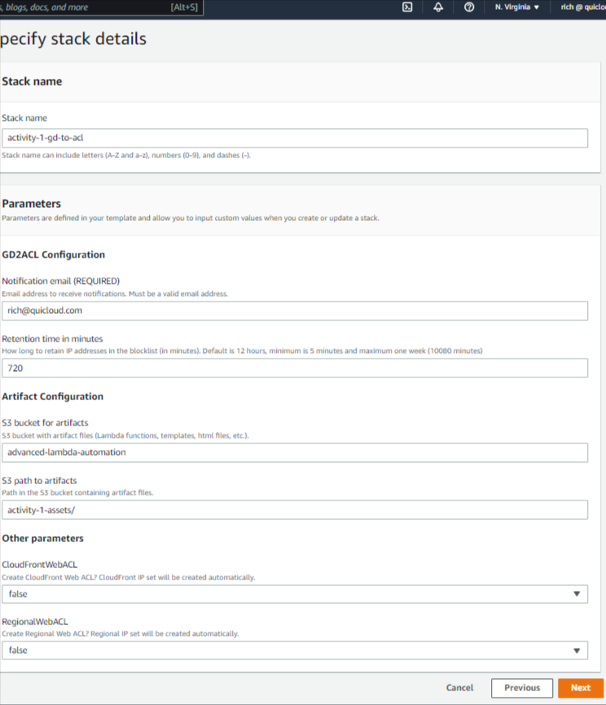At the bottom of the window, you’ll see a terminal. In the terLog into your AWS console and browse to the [Cloudformation console](http://console.aws.amazon.com/cloudformation/), and verify that you are in the us-east-1 (N. Virginia) Region. In the colsole, press “Create Stack” button, then choose “Upload a template file”, and provide the template in the “~/activity-1/templates/guarddutytoacl.template” (wherever you cloned the github repo code for this class). Press “Next”.

On the next page in the flow, under “Stack name”. Give this stack the name “activity-1-gd-to-acl”. For notification email, put in an email you have ready access to while doing the lab. Enter the bucket name and folder of where you uploaded the assets (two lambda functions that will set and delete an IP block) into prior to starting the lab. You can also use rich’s upload area:

Bucket: advanced-lambda-automation

Folder: /activity-1-assets/

Press “Next “ to go to the Configure Stack Options page. Press “Next” on this page as well.

On the final confirmation page, tick the checkbox at page bottom that says “I acknowledge that AWS CloudFormation might create IAM resources.” and press “Create stack”

The stack will take approximately 15minutes to create, so while it’s working your instructor may guide you through the Events, Resources, Parameters, and Templates tabs.

NOTE: Do Not Proceed in the activity until you see “Create Complete” on the ENTIRE STACK.

**Browse the resources that the template launched.**

Open tabs in your browser for [VPC](http://console.aws.amazon.com/vpc/) (then browse to “Security→Network ACLs” in the left rail nav), [Lambda](http://console.aws.amazon.com/lambda/), [AWS WAF](http://console.aws.amazon.com/wafv2/), [DyanmoDB](http://console.aws.amazon.com/dynamodbv2/), and [EventBridge](http://console.aws.amazon.com/events/). Notice the various assets that your CF template created & how they are interconnected. Note that there is currently no WACL and that there were two IPsets created under WAF.

Your instructor will now browse through the Lambda function & describe the function of the various piece-parts and how we may want to extend / enhance in a real production environment.

Your instructor will also describe how the template set up the hooks from GuardDuty to fire the Lambda function (via an EventBridge hook).

**Set up a test event.**

Because GuardDuty findings can sometimes take minutes to generate, we’re going to kick ours off with test of our Lambda function. In order to do that, we’ll have to first configure a test object representing the JSON ‘events’ object that lambda would get passed in the case of a real GD finding occurring. Pull up your Lambda function tab, browse to the “guardduty_to_acl_lambda.py” script, and open the“Code” tab as show below.

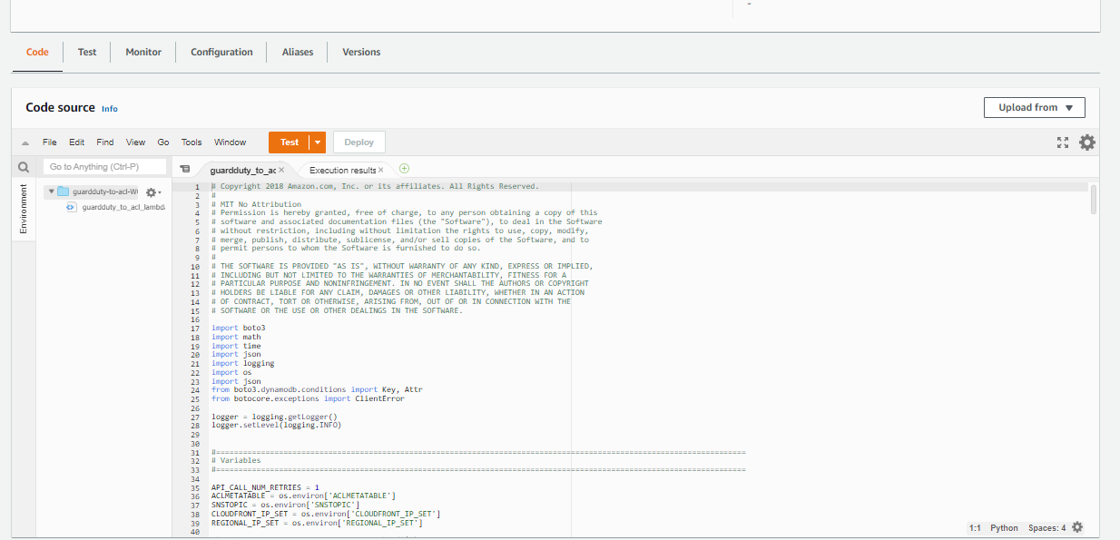

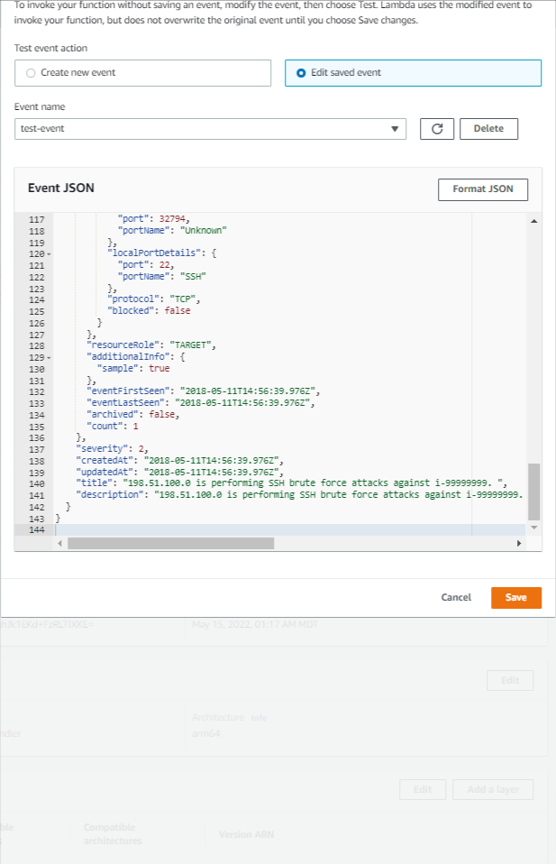

Open the contents of “~/activity-1/templates/gd2acl_test_event.json” in a text editor and browse for “subnetId”. Replace the text “Replace with valid Subnet ID” with a valid subnet from one of your VPCs in this region.

To the right of the orange “Test” button back on the main Lambda page, click the downward facing triangle & choose “Configure test event”. In the popup that appears, give the event the name ‘test-event’ and then paste the “SubnetID” replaced contents of “~/activity-1/templates/gd2acl_test_event.json” over the 4 lines of boilerplate code that is prepopulated. & press the orange “Save” button at the lower right.

Back in the main view of Lambda, press the “Test” button proper. This should leave you with a screen that looks similar to this:

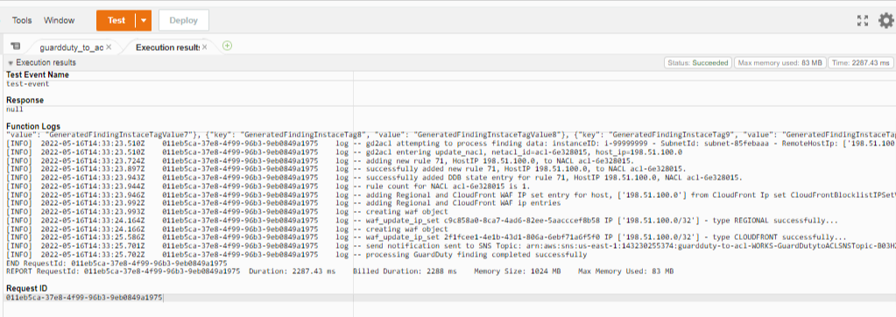

**Validate blacklisting rules**

Verify that the test that you just ran:

* Sent you an email with the Subject line “AWS GD2ACL Alert”
* Entered a rule (probably “71”) in the NACL associated with the subnet you specified, blocking IP address 198.51.100.0/32 .
* Entered an item in the DynamoDB table you created, also for address 198.51.100.0/32
* Entered an IP for the “RegionalBlocklistIPSetV4-XXXXXX“ IPSet that was created earlier

RESOLVE ANY OF THESE ISSUES PRIOR TO PROCEEDING IN THE ACTIVITY

**Remove rules from NACL, DDB**

Because our Lambda code is triggered from the pre-existing rules in the NACL or DDB, let’s delete those entries now & then verify that they are gone. Your instructor will remove the entries from NACL and DDB.

**Verify reachability of instances, load balancer**

If you created instances and a load balancer, verify that all are publicly accessible.

**Create WAF Rule, include IPSet, associate with ALB**

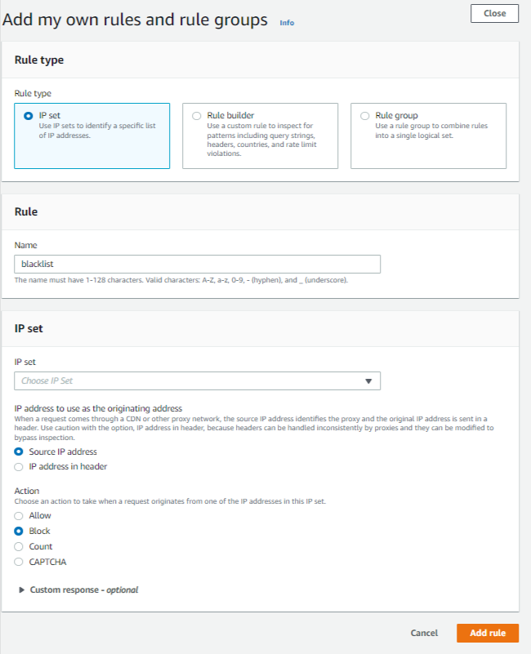Our initial CF template setup didn’t actually create the WAF rule, so let’s go about doing that now. In your WAF console, click “Web ACLs” on the left rail nav & press the “Create web ACL” orange button in the main page. On the next page that appears, give your WACL the name “activity-1-wacl”, accept all other defaults and press “Next”. Add the Load Balancer, if you set one up. On the “Add rules and rule groups” page, choose “Add rules → Add my own rules and rule groups”. On the page that pops up, choose “IP Set”, pick the “IPV4” IP Set, and give the rule the name “blacklist-ips”. Click “Add rule”, “Next”, “Next”, “Next” to get to the final page, then press “Create Web ACL” on the final page.

**Blacklist your own IP**

Browse to [http://whatismyip.com](http://whatismyip.com/) & record the IP address that your machine is known as on the internet.

Open a local copy of your “gd2acl_test_event.json” in a text editor. Making sure to keep the “Subnet ID” replacement you made previously, do a global replace of “198.51.100.0” with your actual IP address. There should be 4 replacements total.

Back in the Lambda interface, overwrite your “test-event” with this new event object. When you run a test this time, it will actually show your IP address as the culprit, and because we’ve now associated this WACL with your load balancer, you should immediately be blocked from seeing the instances or the Load Balancer.

**Questions:**

1. Why are the instances blocked (there’s no WACL associated w/them)?
2. Is there any way we could programatically test this function without causing a real finding to occur?
3. How could we improve our Lambda function?

********* END OF ACTIVITY #1 STOP HERE!!! *********

You now have a good understanding of everything involved with using AWS Lambda with to automatically respond to GuardDuty findings and implement a WAF rule block.

**BONUS Activity #4 (Real world Lambda function in Cloud9 IDE)**

Log into your AWS console and browse to the [Cloud9 area](https://console.aws.amazon.com/cloud9/home/create) (we use us-east-1, but you can switch Regions if you like):

NOTE: As of 2 May, 2022, these are all the default settings.

Environment Name: lambda-automation-basics

Environment type: “Create a new EC2 instance for environment (direct access)

Instance type: “t2.micro”

Platform: “Amazon Linux 2”

Cost-saving setting: “After 30 minutes”

IAM Role: “AWSServiceRoleForAWSCloud9”

Click “Next Steps” until you get to “Review” page,

then click “Create Environment”. You will see messages like “We are creating your AWS Cloud9 environment. This can take a few minutes”, then “Connecting”. When your environment is complete, you’ll see a page that says “Welcome to your development environment”.

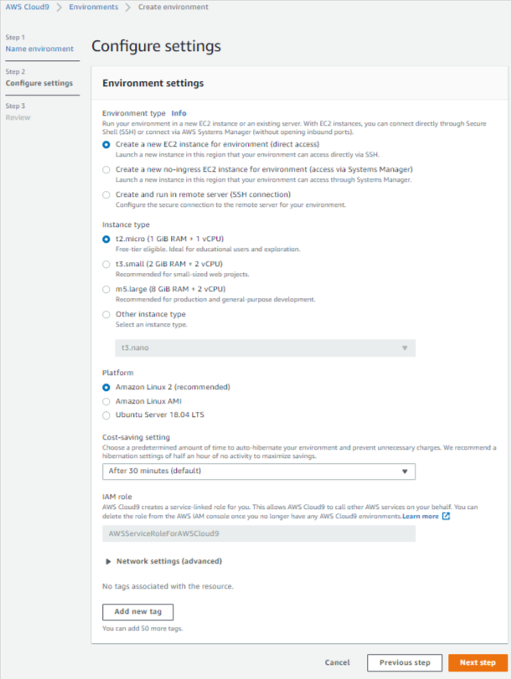

**Git clone the code locally**

At the bottom of the window, you’ll see a terminal. In the terminal, enter:

git clone <https://github.com/rich-morrow/autom8d-foundations.git>

#then cd into the codebase, activity1

cd autom8d-foundations/activity-1

#finally, cat the code out:

cat check-set-tags.py

**Browse the code**

Grab the terminal divider (double lines just above the terminal) and drag it to a larger view so it looks something like this:

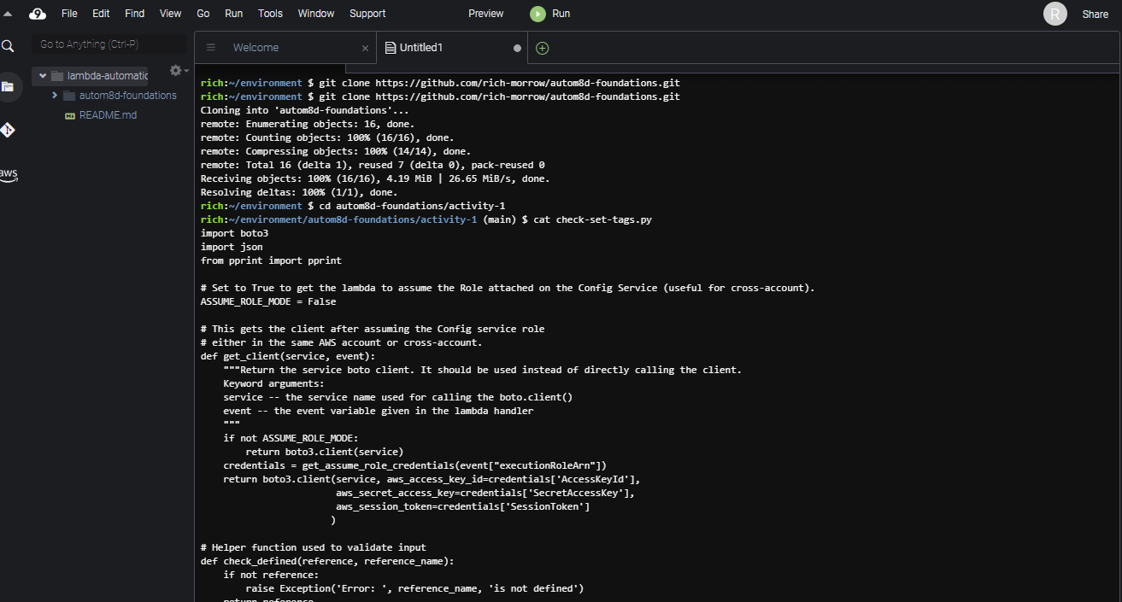

This is basically the code we’ll use for activity #2. For now, don’t worry too much about what it does… let’s open it in Cloud9 by choosing “File→Open”, then selecting “activity-1/check-set-tags.py”. Drag your terminal view down smaller so you can better see the code. As shown below:

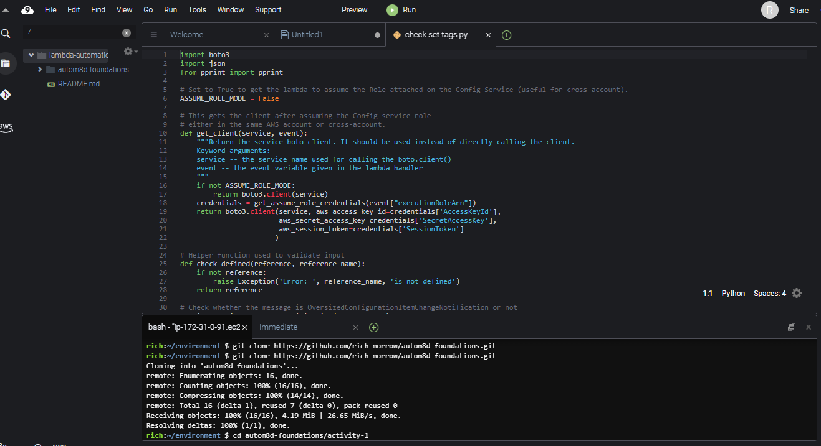

You can attempt to run the code directly by pushing the green “play” button named “Run” at page top, but it will fail as boto3 has not been loaded into our Cloud9 environment. Let’s fix that by doing a pip install in the terminal at page bottom:

pip install boto3

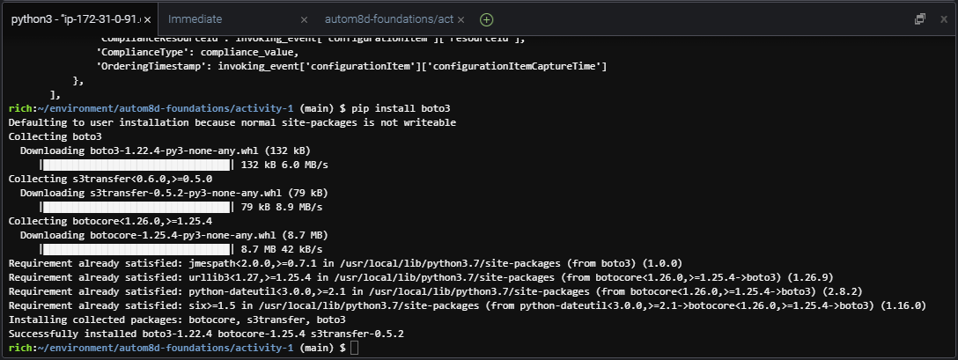Your install should look something like this:

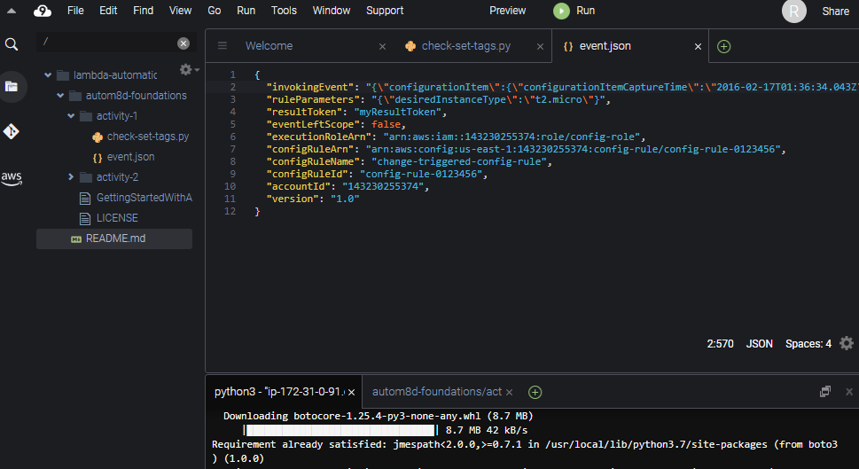

Expand autom8d-foundations→activity-1 in the left hand navigation. Double click the “event.json” object to open it in a new tab. This event object is a mock of what would be passed to the Lambda function in a real, live execution. We can alter it later on if we choose

select the “check-set-tags.py” tab to look at our code again. Notice how there are several “def” functions defined. Your instructor will walk through each, describing at a high level what’s going on.

Note, also that since we’re running this code in the IDE, we have to:

1. Manually load our events.json code (lines 208,209)
2. Directly invoke our “lambda_handler” method (line 213). When this function runs natively in Lambda (as you’ll see in Activity #2), you’ll see that “lambda_handler” is what is called automatically for us by the Lambda service.

Also, we should point out that if you’re doing a lot of local development and/or dealing with event objects frequently, there is a more elegant way to do this – with the SAM CLI. Although what we’ve done here will work just fine for our demo purposes (and it also nicely highlights some python operations like file open, read, etc), if you want to learn the “right way” to deal with Lambda in Cloud9, check out this AWS user guide: [Working with AWS serverless applications using the AWS Toolkit](https://docs.aws.amazon.com/cloud9/latest/user-guide/serverless-apps-toolkit.html).

Now that boto is installed, we should be all ready to run our code. With our focus on the “check-set-tags.py” tab, let’s hit “Run” again at the page top!

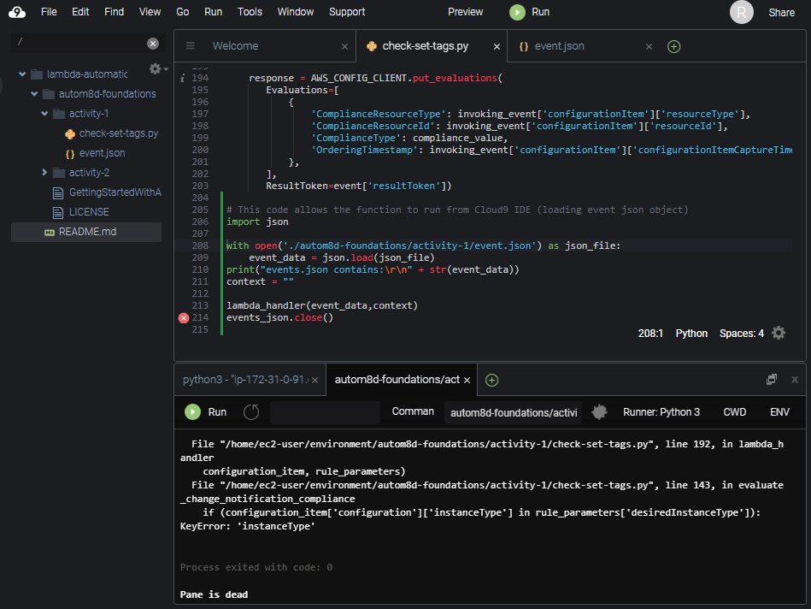

Uh oh. We see errors again: “KeyError: ‘instanceType’”. This time, however, the error is expected (our “Configuration” object doesn’t have an expected “instanceType” for the mock. We can correct this, but then we’ll see other errors for “tags”, etc. For our purposes, this is just fine. We’ve validated that our code works… it’s just a bad “events” object being passed in. In Activity 2, we’ll see proper operation of this code when we come back and watch it run in a live scenario with real “Configuration” data passed into it from AWS Config.

********* END OF ACTIVITY #4 STOP HERE!!! *********

You now know basic operation (env create, terminal usage, code loading/running/debugging) of Cloud9, and you’ve gotten some experience with a fairly advanced Lambda function.

**BONUS Activity #5: Automating tag enforcement with AWS Lambda and AWS Config**

In this lab, we’re going to set up our ‘check-set-tags’ Lambda function to automatically be invoked by AWS Config when it detects any configuration change on our EC2 instances. The pseudocode for this function looks like:

foreach ec2 instance {

if(instance is approved instanceType) {

if(instance is tagged with “env=prod”) {

if(instance is not tagged with “owner”) {

tag instance with “[owner=rich@quicloud.com](mailto:owner%3Drich@quicloud.com)”

}

mark COMPLIANT and EXIT

} else {

stop instance

}

mark NON_COMPLIANT

}

COMPLIANT OR NON_COMPLIANT will appear in the AWS Config Dashboard, as well

**Start up two (or more) EC2 instances**

Before we start our function running, we’ll need some test instances for the script to check. In the AWS Console, browse to EC2, and start up two instances. One of size t2.micro, and one of size t3.nano. You may still have a t2.micro running from activity 1 where we played with Cloud9. If desired, you may also start instances of other sizes as well (just be careful… larger instance types can incur significant costs in AWS). Once your instances are started, you should see something like this below (we still have our Cloud9 instance running).

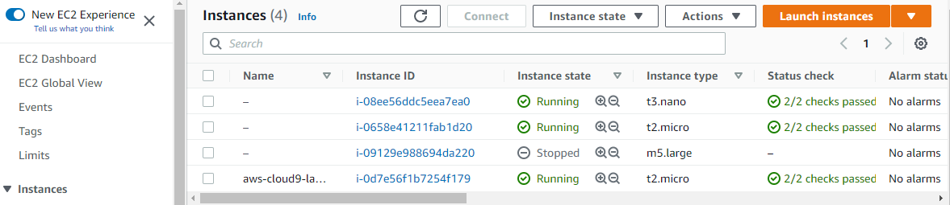

**Create appropriate Lambda role**

The Lambda function we’ll use needs proper ***execution permissions*** to perform all of it’s interactions with other AWS Services. We’ll use our pre-created policy document to create a role. From the git package you downloaded earlier (we just used the Cloud9 bash shell), browse into the ‘activity-2’ directory and run a directory listing.

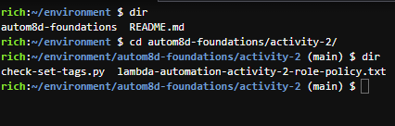cd autom8d-foundations/activity-2/

dir

cat out the contents of the ‘lambda-automation-activity-2-rolepolicy.txt

cat lambda-automation-activity-2-role-policy.txt

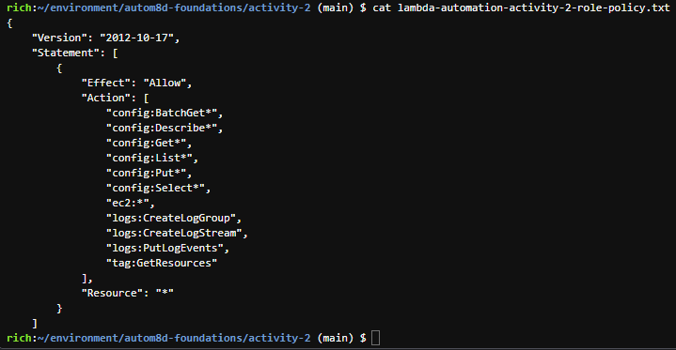Copy the entire statement (from opening “{“ to closing “}”) into your copy buffer with CTRL-C. Your instructor will take a moment to explain the various ramifications of the statements inside of the document.

Back in your browser, open another tab to the [IAM service](http://console.aws.amazon.com/iam). Browse to “Policies” on the left hand navigation.

You should see a view that looks similar to:

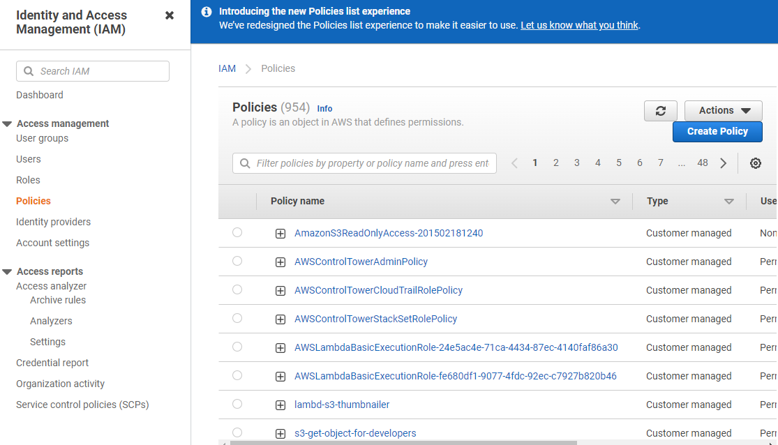

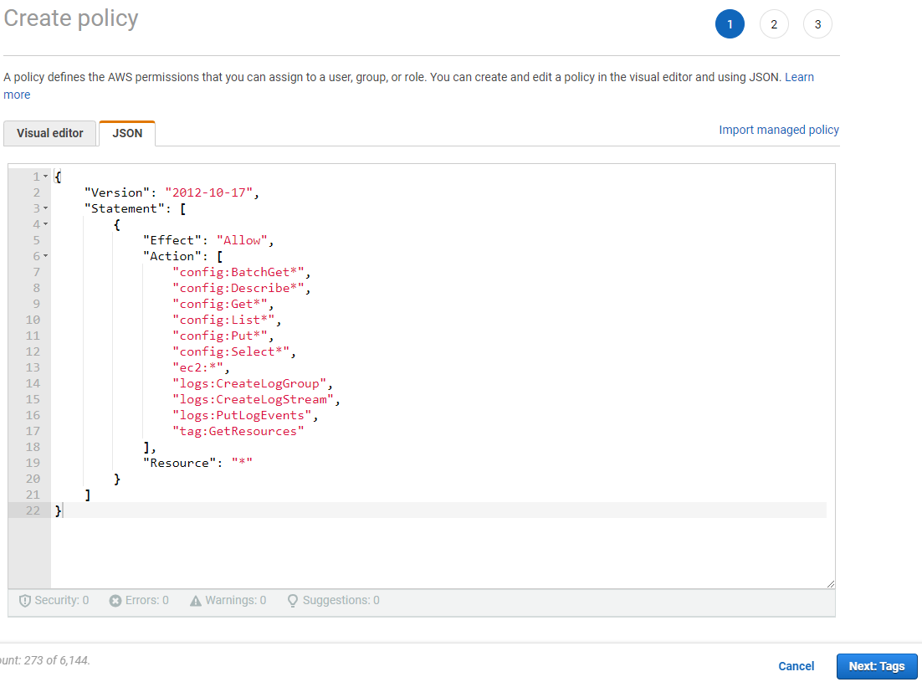Click the “Create Policy” button on the upper right, choose the “JSON” tab, and paste in the policy document you copied above, overwriting the stub that was pre-entered.

Click “Next: Tags”, then “Next: Review”. Give the policy a name of “activity-2-lambda-automation-basics-policy”. You can give a description if you like. Then push “Create policy” button

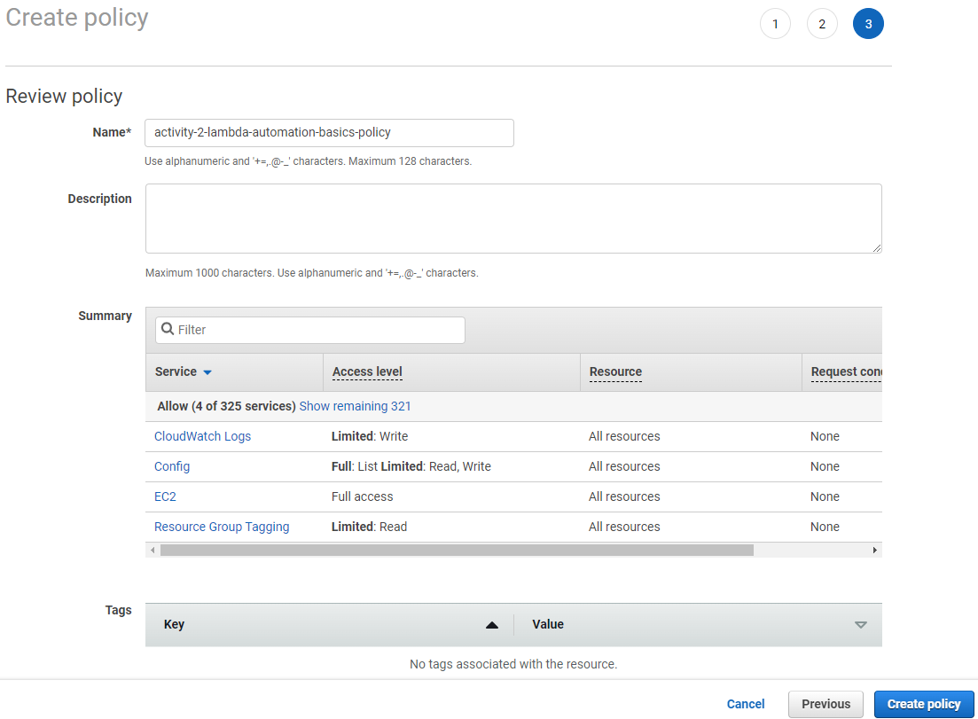

Now we’ll attach this policy to a role that Lambda will assume when it needs to.

From the left hand nav in IAM, select “Roles”. And click “Create role” button in upper right.

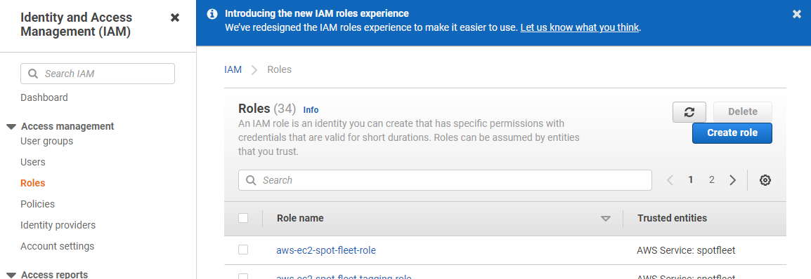

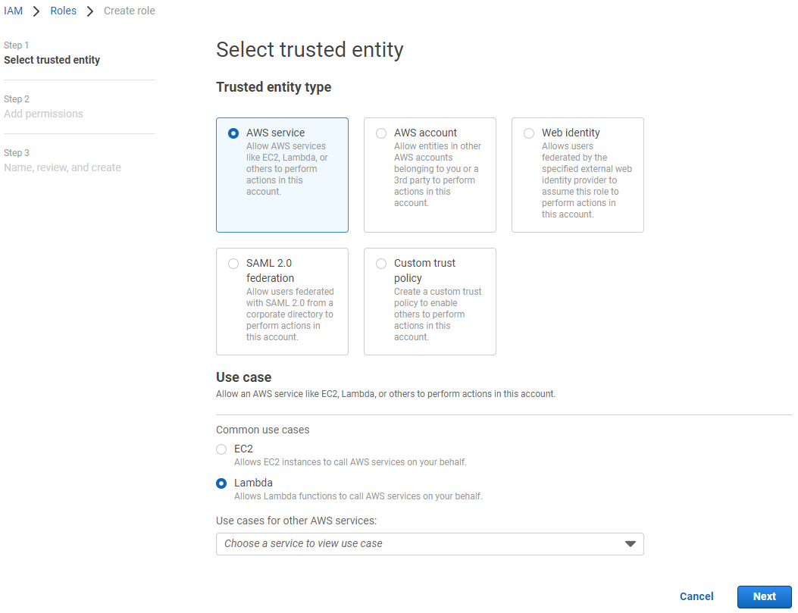

For “Trusted entity type”, choose “AWS service”, and for “Use case” choose “Lambda”, then push “Next”.

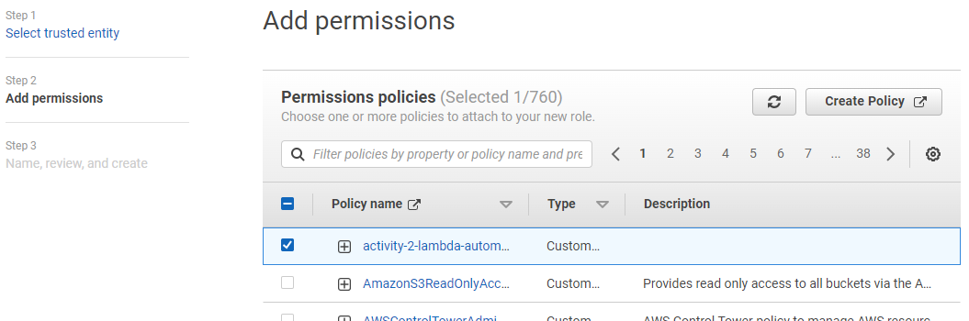On the “Step 2: Add permissions” page, select the “activity-2-lambda-automation-basics-policy” that you entered before (it should appear at the top of the list). If you do not see this policy, you must repeat the steps above to enter the policy correctly. Push “Next” button.

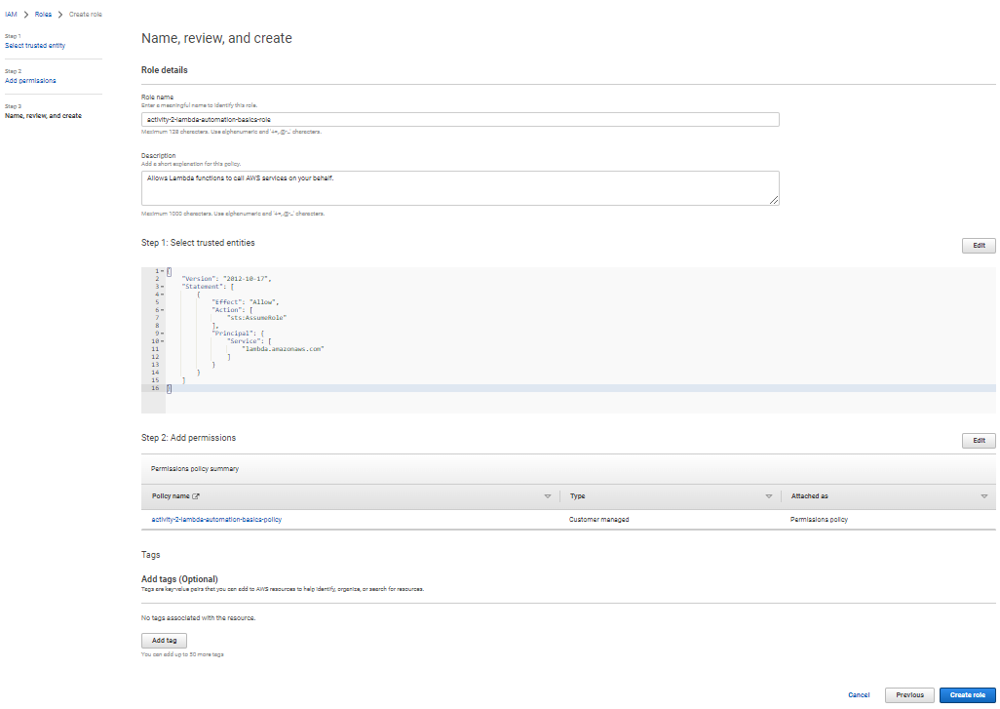On the “Step 3: Name, review, and create” page, name your role “ activity-2-lambda-automation-basics-role”, give it an optional description, and then press “Create role” button to finalize the creation.

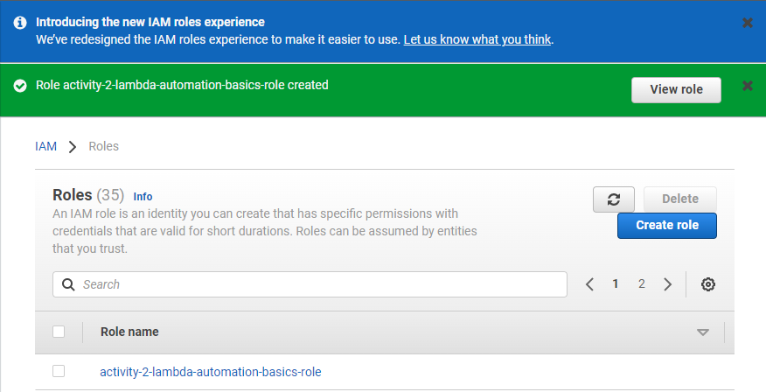You should finally see a screen that looks similar to the following, showing that your role has been successfully created.

**Create our Lambda function**

Now that we have the appropriate permissions (the Lambda role) for our function to work, we can go ahead with the creation of the function itself. From wherever you installed the git package for this class, cat out the ‘’check-set-tags.py” python code.

cat check-set-tags.py

Copy the entirety of this code (from “import boto3” at top to “resultToken’])” at bottom) by selecting it and pushing CTRL-C to copy it into your clipboard.

Open a new tab in your browser, and browse to the [Lambda section of the console](http://console.aws.amazon.com/lambda/). Press “Create function” button in the upper right.

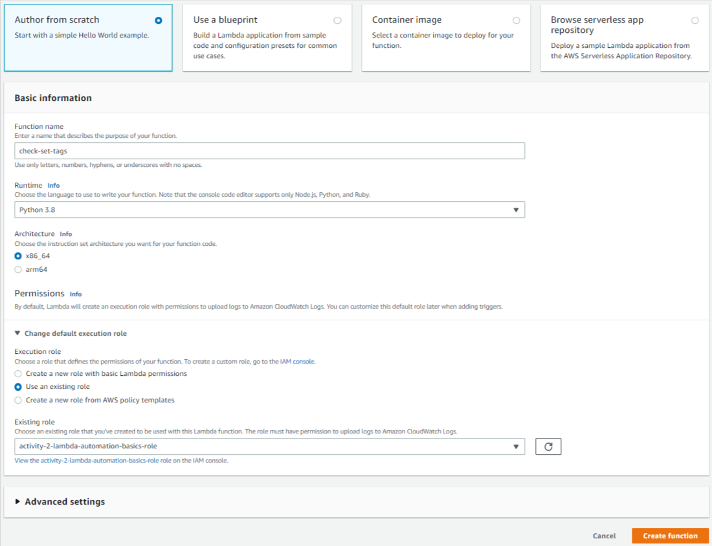Choose “Author from scratch”, give your function the name “check-set-tags”, Choose the runtime of “Python 3.8”, and under “Permissions”, expand “Change the default execution role”, choose “Use an existing role”, then select your “activity-2-lambda-automation-basics-role” from the list. Then push the “Create function” button.

On the next page, under “lambda_function” under “Code source”, paste your “check-set-tags” code in the area, overwriting the stub that was pre-entered. NOTE: Your changes ARE NOT LIVE until you push the “Deploy” button. Whenever you make changes to your code, make sure to always push the “Deploy” button to push it live. Go ahead and push the “Deploy” button as well.

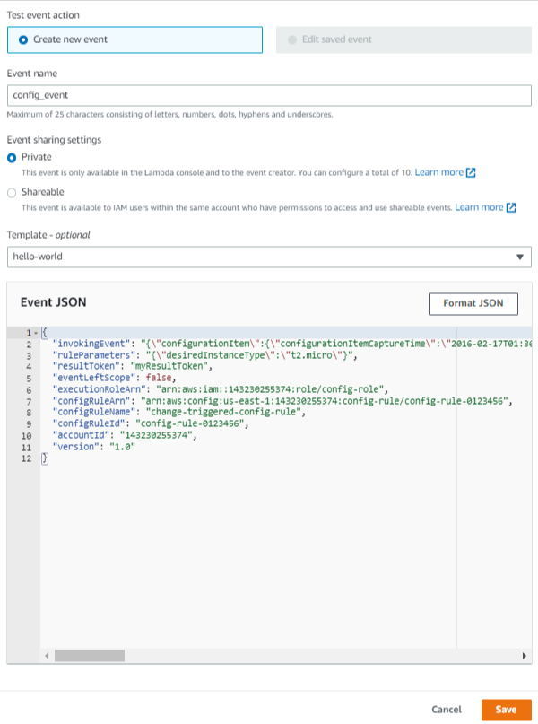

Select the dropdown to the right of the “Test” button, and choose “Configure test event”. Copy the contents of our “events.json” object from activity-1 into the “Event JSON”, and give the event the name “config_event” and press “Save”.

Now that we have a valid test object to test with, go ahead and press the “Test” button under Code source. You should see output that looks similar to the following. Notice that we see the same “instanceType” failure that we had from activity 1. This is to be expected, and at least validates that our function is set up correctly, the code is working properly, and that our function has the appropriate permissions to do what it needs to do.

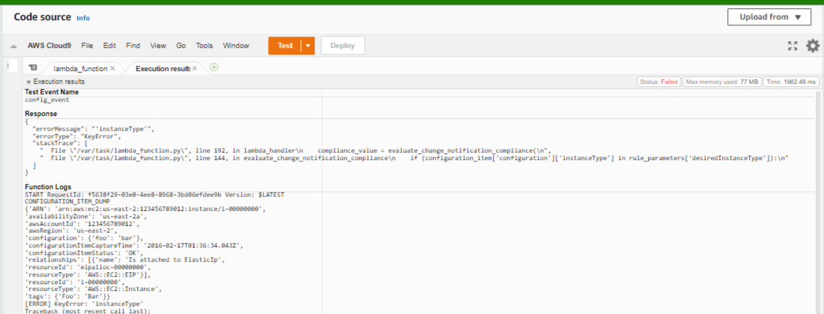

**Create custom AWS Config rule using our Lambda function**

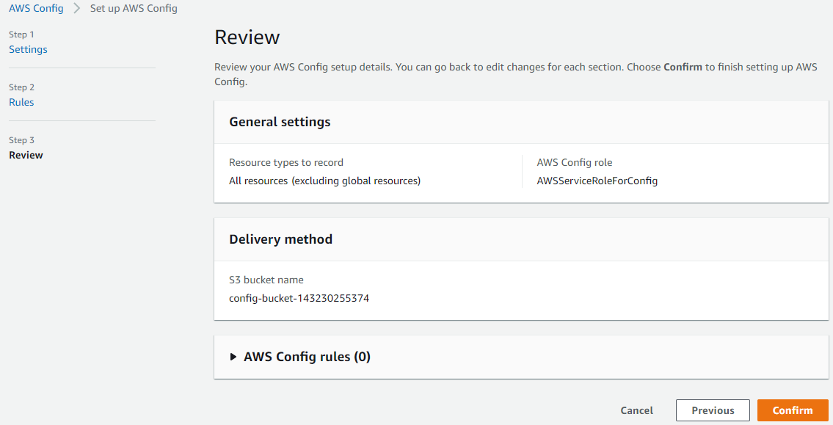We’ll now set up AWS Config to monitor our EC2 instances, reporting in-or-out of compliance for the instances in the Config Dashboard. First, open a new tab in your browser and browse to [AWS Config](http://console.aws.amazon.com/config/) in that tab. Click “1-click setup” button, then push “Confim” (accepting all defaults) to enable AWS Config.

Now that config is enabled, you should see a dashboard that looks similar to the following.

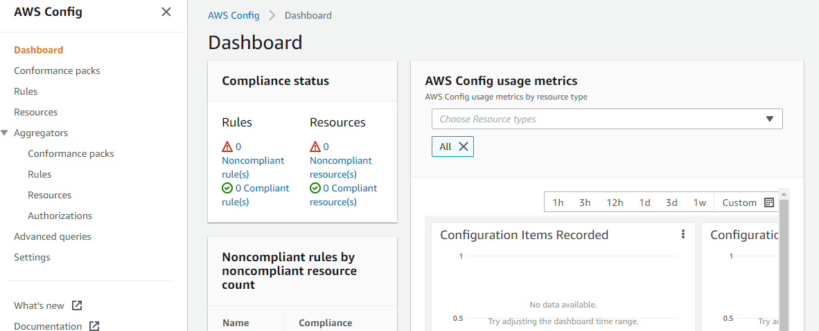

From the left-hand navigation, select “Rules”, then push the “Add rule” button. On the next screen, choose “Create custom Lambda rule” and press “Next”

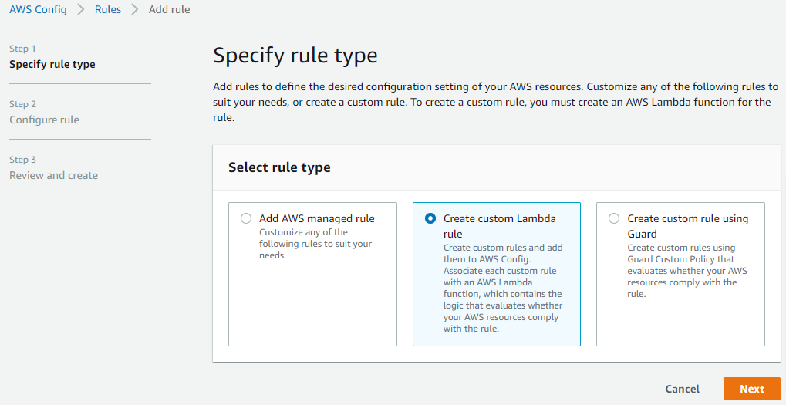

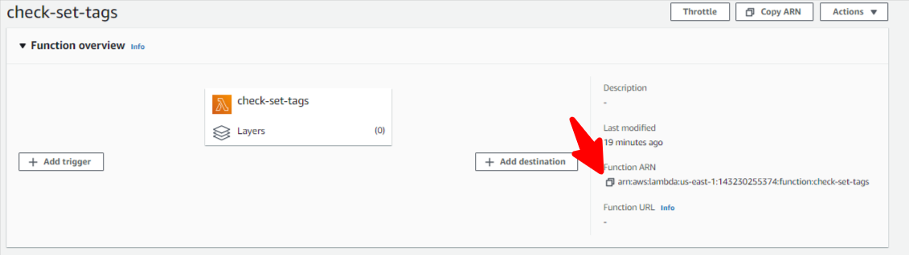

Back on your Lambda browser tab, copy the ARN of your “check-set-tags” lambda function by pressing the “copy” icon as shown in this screenshot:

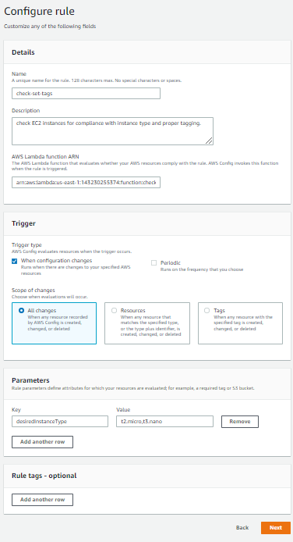Back in your AWS Config tab, give your rule the name “check-set-tags”, give it a description, paste your ARN under “AWS Lambda function ARN”, select “Trigger type” of “When configuration changes”, and then under parameters, set a “Key” of “desiredInstanceType” and a value of “t2.micro,t3.nano”. These Config parameters are hooked into our Lambda function to control the instance types we allow in our account, and you are welcome to change them later.

Press “Next” button, then on the Confirmation page, press “Add rule” button to finally add the rule.

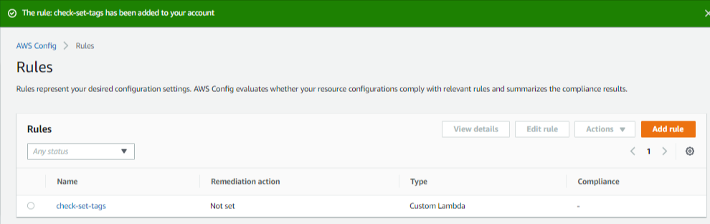You should now see the following:

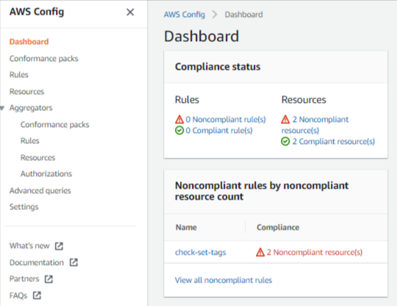

And if you click back into Dashboard from the left hand nav, you should now start to see Compliance / Non-Compliance for your assets as so:

**Test our Config Rule by tweaking EC2 tags**

In your browser, open a new tab for CloudWatch Logs. We’ll revist this tab frequently as it’s where our “print” statements from our Lambda function will land.

Iteratively re-visit your EC2 tab in your browser, and try the following:

1. Set “env” tag to “prod” (then watch Config/Lambda tag your instances with “[owner=rich@quicloud.com](mailto:owner%3Drich@quicloud.com)”)
2. Set “env” tag to anything besides prod (then watch Config / Lambda stop your instances)
3. Start new EC2s with proper “env=prod” “[owner=your@email.com](mailto:owner%3Dyour@email.com)” and watch them go compliant in the Config Dashboard.

**Questions:**

1. What are some limitations of Config (can it check all resources, is it “real-time”)?
2. If we needed real-time, or other resource checking, what might be a better service?
3. How could we improve our Lambda function in a real-world environment?
4. How could we improve our permissioning of our Lambda function?

********* END OF ACTIVITY #5 STOP HERE!!! *********

You now have a good understanding of everything involved with using AWS Config with custom Lambda functions to programatically and proactively enforce tagging policies.

**Activity #6: Automating EC2 log processing and alerting**

In this lab, we’re going to use a CloudWatch Logs agent to ship the /var/log/secure SSH logs into CloudWatch Logs. We’ll then route specific log entries to a Lambda to trigger with CloudWatch Subscription Filters. The Lambda function will log when unauthorized SSH attempts happen on our server.

NOTE: Previous versions of our slides for this class referenced an “EventBridge” solution. This activity has been changed to simply use CloudWatch Subscription Filters as they are a much more elegant solution for this particular use case.

**Create CloudWatch Logs Role & launch EC2 Instance**

1. Follow the documented [AWS instructions](https://docs.aws.amazon.com/AmazonCloudWatch/latest/monitoring/create-iam-roles-for-cloudwatch-agent.html) (Create IAM roles to use with the CloudWatch agent on Amazon EC2 instances) to create the role necessary for our EC2 instance to write it’s logs to CloudWatch Logs. At the end of the process, you will have created a role called “CloudWatchAgentAdminRole”
2. From the AWS EC2 console, launch a t2.micro instance with Amazon Linux (or, optionally re-use one of the ones from activity #2, if you still have it). Give the instance the name “activity-3”. Under “key pair name”, choose “Create a new key pair”, and give the keypair the name “activity-3”. If you use linux to SSH, leave the default “.pem”, or if you use Putty to SSH, select the “.ppk” option. Your keypair will download locally – note the location it saved to as you’ll need it later. Expand “Advanced details”, and under “IAM instance profile”, select the “CloudWatchAgentAdminRole” you created above. Accept all other defaults (including “Allow SSH traffic from Anywhere” – generally a BAD idea!). Note this instance ID.
3. 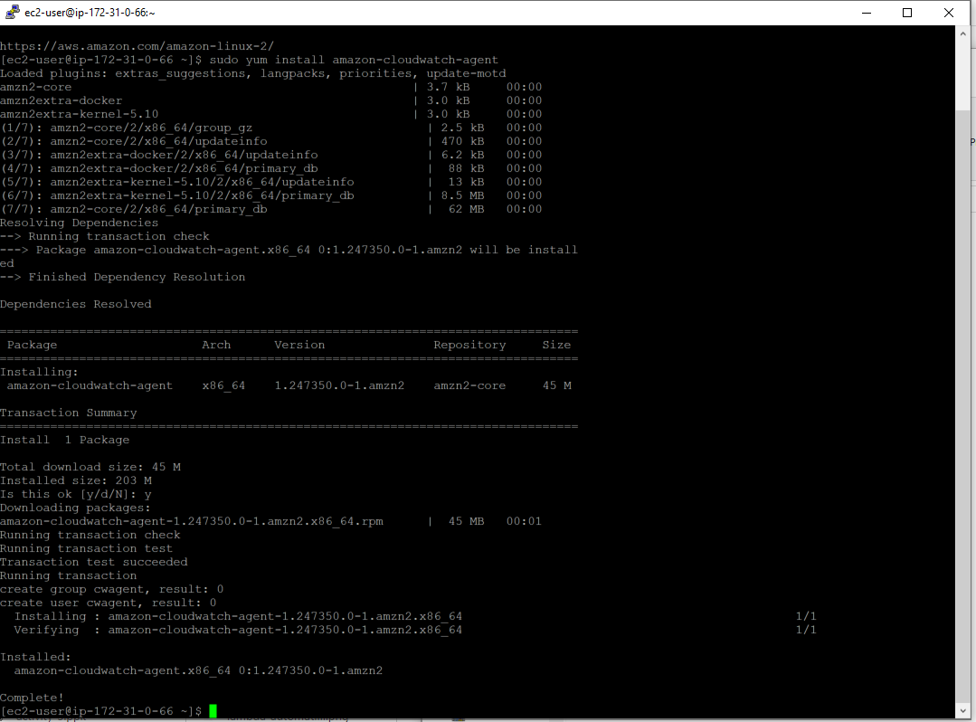SSH into your “activity-3” instance (user is “ec2-user”), and then install the cloudwatch agent (it’s a standard package

sudo yum install amazon-cloudwatch-agent

Once the command runs, you should see the output as shown on the right.

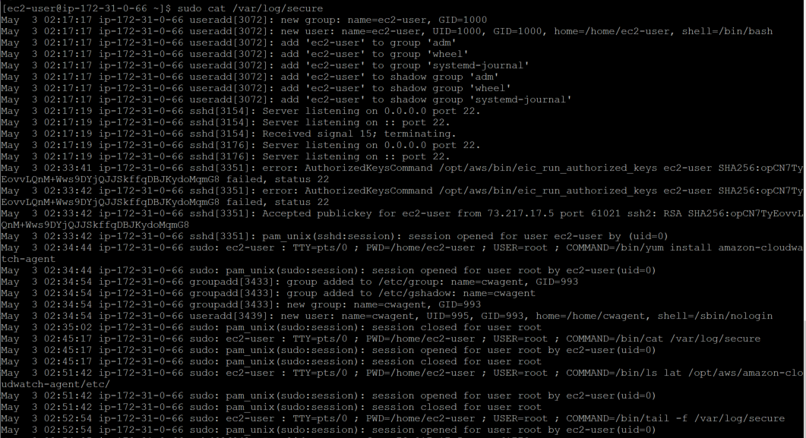**Configure CloudWatch Logs Agent**

The logfile that we’re going to analyze is /var/log/secure on Amazon Linux 2. This log has all the entries whenever an SSH attempt is made against this server. Cat the file out to see our current logged in session.

sudo cat /var/log/secure

Now, let’s tail the log file to see what an invalid access would look like.

sudo tail -f /var/log/secure

Open a 2nd putty session to this server, and attempt to log in with another user than the authorized “ec2-user”. In the example below, we’re trying to lgin as the user “xyz”. Note the failed “invalid user” line.

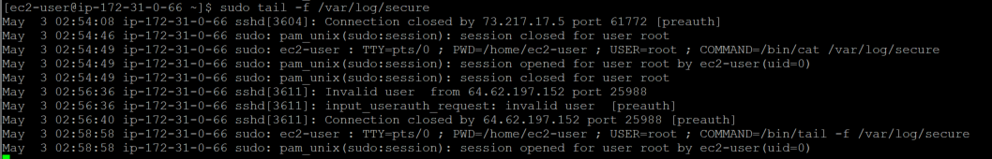

Let’s now configure the CloudWatch Logs agent to ship these logs into CloudWatch. The CloudWatch Agent installs under /opt/aws/amazon-cloudwatch-agent/, so we’ll update our configuration there. The configuration files we’ll create will be stored under the “/etc” directory in that path, so let’s cd into there first and browse the contents.

cd /opt/aws/amazon-cloudwatch-agent/etc

ls -lat

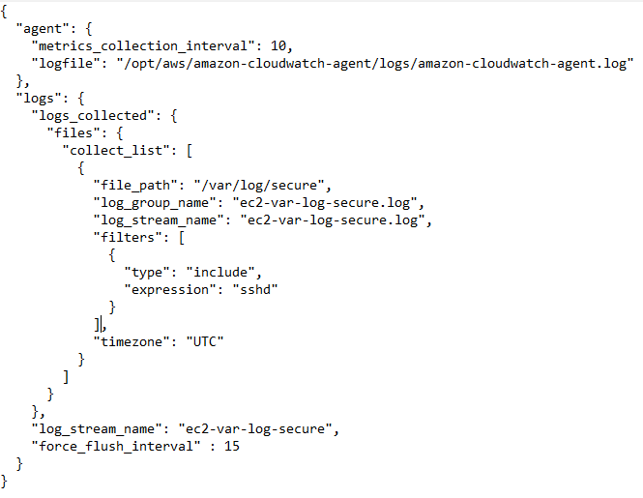You’ll only see two one file in there currently, “common-config.toml”, and one directory “amazon-cloudwatch-agent.d”. Following AWS recommendations, we’ll install a config file here named “amazon-cloudwatch-agent.json”. Copy the contents of our git “/activity-3/amazon-cloudwatch-agent.json” file into here (using vi, nano, or whatever editor works for you. NOTE: It may be faster/easier to “git clone” our base code on this server and copy the file directly if you have problems with copy/paste in your SSH client). Your instructor will now pull up the contents of the file and walk you through the details.

Once you’ve browsed the file contents and you’re aware of what they each do, we’ll go ahead and start our cloudwatch agent with the following command:

sudo /opt/aws/amazon-cloudwatch-agent/bin/amazon-cloudwatch-agent-ctl -a fetch-config -m ec2 -s -c file:/opt/aws/amazon-cloudwatch-agent/etc/amazon-cloudwatch-agent.json

To ensure Cloudwatch started correctly, let’s first look at our log file…

sudo cat /opt/aws/amazon-cloudwatch-agent/logs/amazon-cloudwatch-agent.log

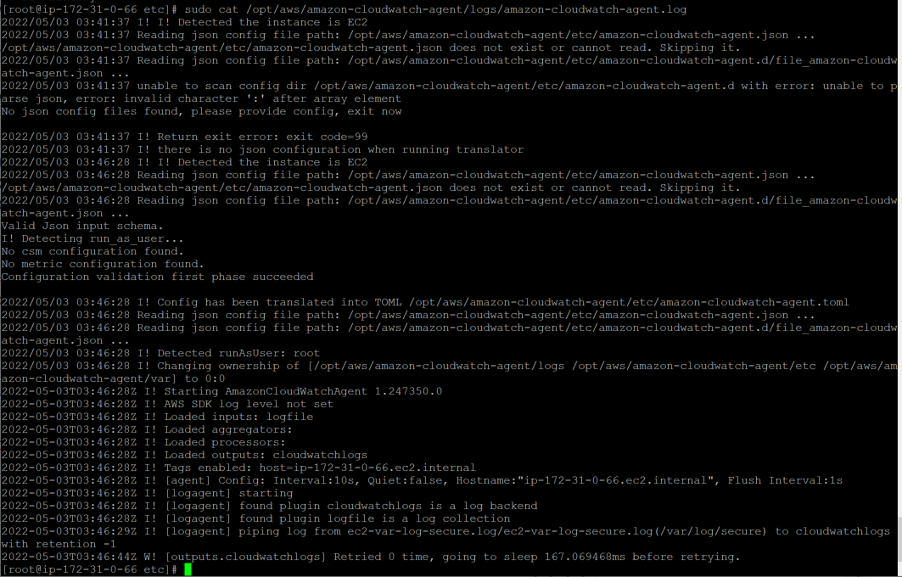If the agent started successfully, we should see something similar to the output at the right.

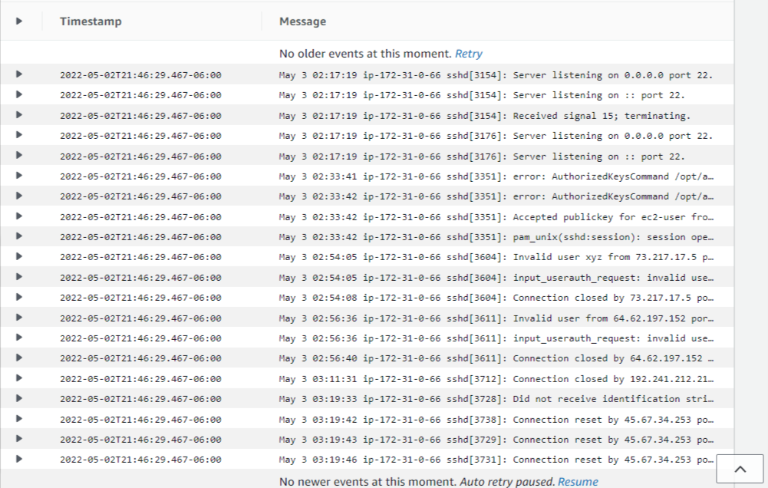The true test of whether or not everything has been set up correctly to date (including the EC2 role), is to actually browse the CloudWatch Logs consolerect operation. Browse to the [CloudWatch Console](http://console.aws.amazon.com/cloudwatch/), select “Log groups” under “Logs” on the right-hand navigation, and then click on our “ec2-var-log-secure.log” group. Once you see the group, click on the stream under “Log streams” (Note: We only have a single stream here, because we only have one agent running on one server. If we had several servers running an agent each, we’d see multiple log files). Click on the single “ec2-var-log-secure.log” stream to view it’s contents. It should look similar to what we see on the right (showing that we only captured entries which match ‘sshd’).

If you like, you can attempt another failed SSH connection to see another “Invalid user [user-name]” message appear in the logs.

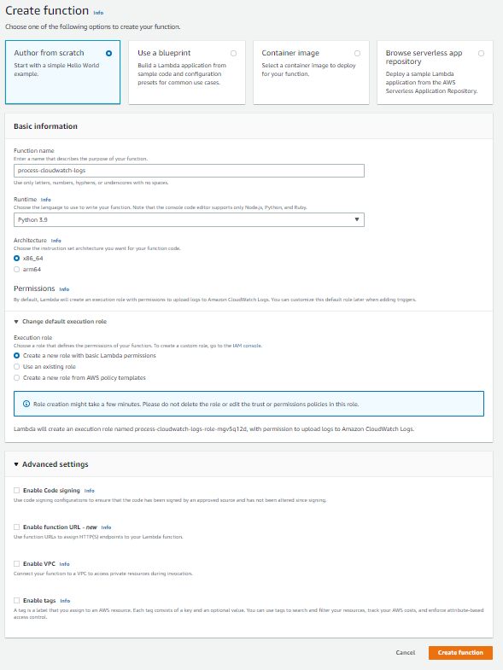**Create Lambda function to process Invalid SSH attempts.**

Using the steps you went through in activity #2, go ahead & create a 2nd lambda function, using the screenshot at right as a guide. Once the function is created, go ahead & paste the code for “process-cloudwatch-logs.py” into the function & deploy it by pressing the “deploy” button. We could create an event object to test the code with, but we’re just going to go ahead & create a CloudWatch subscription filter which is actually probably faster than even testing.

**Create CloudWatch subscription filter to call Lambda log processor and respond to events in EC2 logs**

Back in the CloudWatch Console, click “Log groups” under Logs in the right hand nav, tick the checkbox next to “ec2-var-log-secure-log”, and then from the “Actions” dropdown, choose “Subscription filters→Create Lambda subscription filter”. If you’re confused, use the screenshot below as a guide.

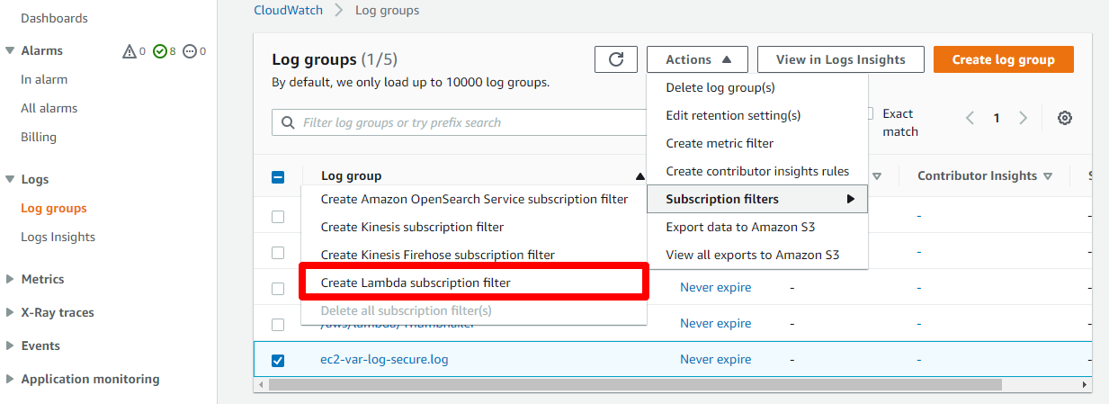

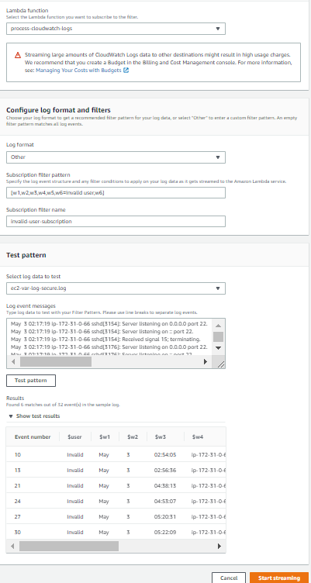On the next page, point the subscription to our function (process-cloudwatch-logs), use “Other” log format, set the “Subscription filter pattern to” “[w1,w2,w3,w4,w5,w6=Invalid user,w7]” (your instructor will explain this pattern in detail), give the subscription a name (we used “invalid-user-subscription”), then under “Test pattern”, select our “ec2-var-log-secure.log” log, and push the “Test pattern” button to validate our Subscription filter pattern.

You should only see the results that match “Invalid user”, and you can see that we’ve tested our results (on the right) with several failed SSH attempts.

If all looks good, go ahead & press “Start streaming” to connect this final piece of our activity.

You’ll be redirected back to the “Log groups” page with a message saying “LLog events streamed to Amazon Lambda.” at page top.

**Validate operation of solution**

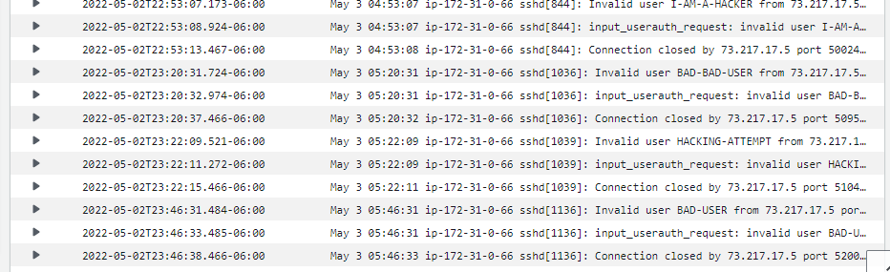Attempt to SSH to this server again, but this time do not supply the valid name “ec2-user”. Try to log in with anything else like “BAD-USER” or “HACKING-ATTEMPT”. Immediately after failed logins, you should see the appropriate entries in “ec2-var-log-secure.log”. Here’s what ours looked like after a few attempts:

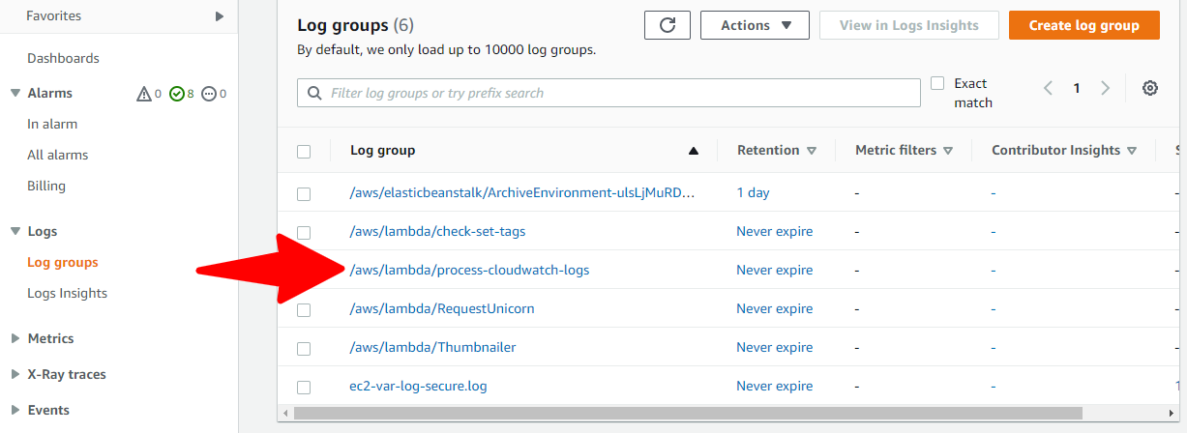

After 10-20 seconds, back in “Log groups”, you should see a new log group appear “process-cloudwatch-logs”.

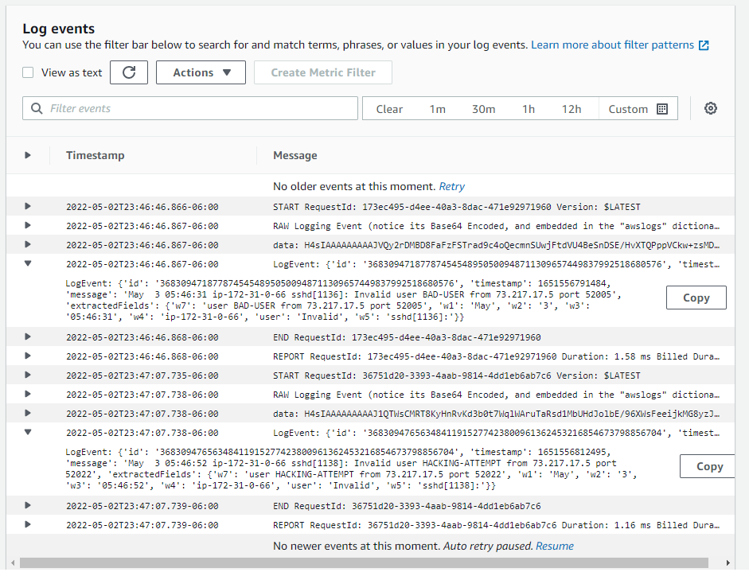Go ahead & click into that group, click into the stream to view the entries inside. You should see something similar to our results on the right.

You can expand out the “LogEvent” entries to see what matched our patterns (note these are the ONLY entries that matched) and what was placed into the w1,w2, etc variables.

This solution could easily be extended to allow Lambda to notify us (via SNS), update a dashboard (which we’ll do in the next lab), Add the remote IP to a WAF or SG rule block, etc…

The possibilities are endless!!!

********* END OF ACTIVITY #6 STOP HERE!!! *********

You can now set up an end-to-end log capture, ship, and analysis toolchain using CloudWatch Logs Agent, CloudWatch subscription filters, and Lambda.

**BONUS Activity #7: Automating GuardDuty and EventBridge alerts to update CloudWatch dashboards**

In this lab, we’re going to set up a ‘guard-duty-check’ Lambda function to automatically be invoked by Amazon EventBridge when it EventBridge detects any GuardDuty finding occurance in the high, medium, or low severity category. Our Lambda function will be invoked once per finding. The function additionally updates a CloudWatch dashboard with the count of the findings. Pseudocode for this function looks like:

get_high_medium_low_counts_from_current_dashboard {

determine_severity_of_this_finding()

increment_relevent_severity()

send_sns_notice_of_finding()

update_current_dashboard()

}

**Create SNS Topic, subscribe your email**

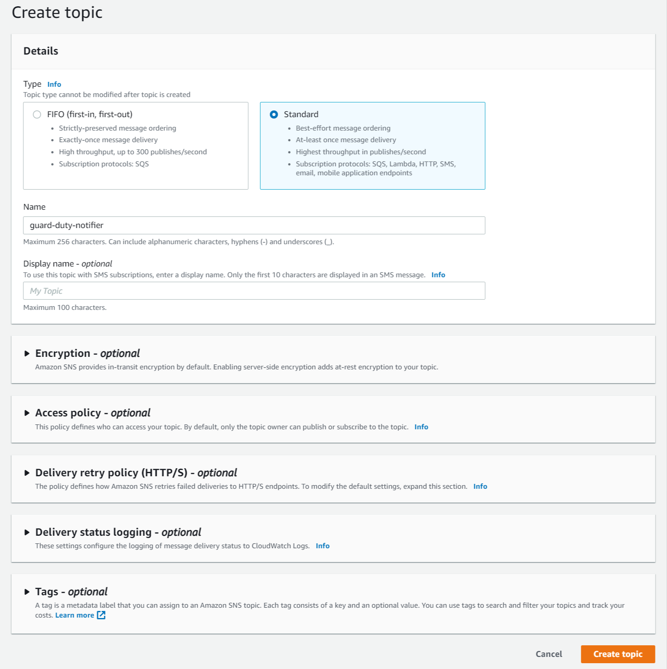Browse to the [SNS console](http://console.aws.amazon.com/sns/), click “Create topic”, choose “Standard” as Topic type, give the topic the name “guard-duty-notifier”, and press “Create topic” button.

You should see a message at the top of next page that says “Topic guard-duty-notifier” created successfully.

On this page, click the “Create subscription” button. For “Protocol”, choose “Email”, and enter an email that you have access to in the “Endpoint” text entry field. Click “Create subscription” button at bottom of page.

This email will have to be confirmed before you can start to receive email from Amazon. Flip over to your email client, and find the email that Amazon just sent to you.

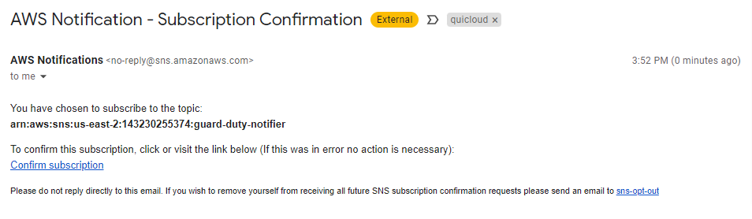Click the link in the email that says “Confirm subscription” to verify that you own this email.

You’ll be directed to a page at AWS that says “Subscription confirmed!”.

**Enable GuardDuty**

In another tab in your browser, open the [GuardDuty console](http://console.aws.amazon.com/guardduty/), click the “Get Started” button, and then click the “Enable GuardDuty” button to turn GuardDuty on in this Region. (NOTE: AWS gives you a 30day free trial of GuardDuty, which is more than enough to perform the lab for free. Please make sure you drop a note in your calendar to disable GuardDuty before this 30 days runs out so you do not get charged for the service).

You’ll be directed to a “Findings” page that looks something like below.

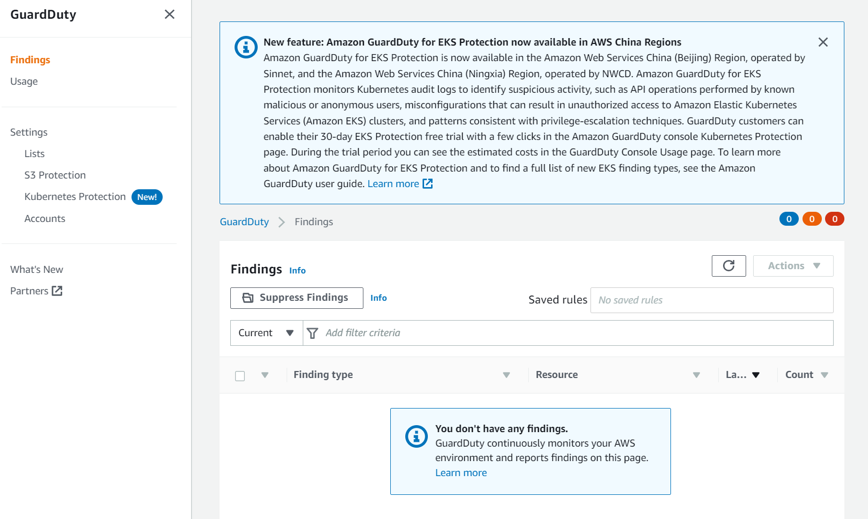

We’ll come back to this console later to generate some sample findings, but for now, let’s just leave this tab open.

**Create CloudWatch Dashboard**

If you haven’t yet, browse into the “/activity-4/” directory in the github package you downloaded for this class. You’ll copy some assets from here into various places in the console and other areas in AWS.

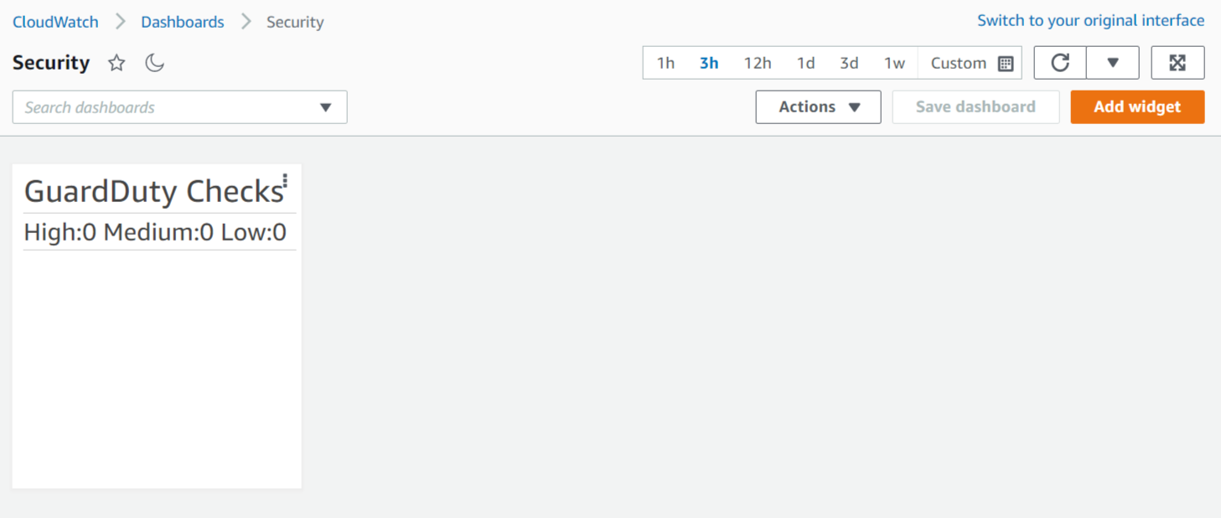Open (yet) another tab in your browser, and in that tab, browse to the [CloudWatch console](http://console.aws.amazon.com/cloudwatch/). From the left rail nav, click on “Dashboards”, then click on the “Create dashboard” button in the main page. Give the dashboard the name “Security”. On the “Add widget” popup that immediately appears, choose the “Text” widget, and in the “Markdown” area, copy and past the text that appears in the “/activity-4/cloudwatch-dashboard.txt”. Push the “Create widget” button, then push the “Save dashboard” button to finish the dashboard creation. You should finally be presented with a page that looks like this:

**Create Execution Role for Lambda function**

Open another tab in your browser, and in that tab, browse to the [IAM console](http://console.aws.amazon.com/iam/). Choose “Policies” from the left rail nav. Click the “Create Policy” button in the main window. In the page that appears, click the “JSON” tab at page top, and paste the text from “/activity-4/activity-4-lambda-policy-document.txt” over the JSON stub that’s pre-populated here. MAKE SURE TO CAREFULLY REPLACE YOUR “REGION” AND “ACCT ID” over the appropriate places in the “Resource” line for the “sns:Publish” action. You’ll get “ACCT ID” by selecting your “user @ acct” from the far upper right dropdown in the console, and the Region is what you’ve been using for this entire lab (make sure you use the AWS programmatic identifier like “us-east-1” rather than “virginia”). For example, if your Acct ID was “123456789012” and your region was Oregon, your full identifier for that line would look like this:

"Resource": "arn:aws:sns:us-west-2:123456789012:guard-duty-notifier"

Press the“Next:Tags” button to advance to the next step, Press “Next:Review”, give the policy the name “activity-4-lambda-policy”, then press “Create policy”.

You should see a green “The policy activity-4-lambda-policy has been created” notice appear on the next screen”.

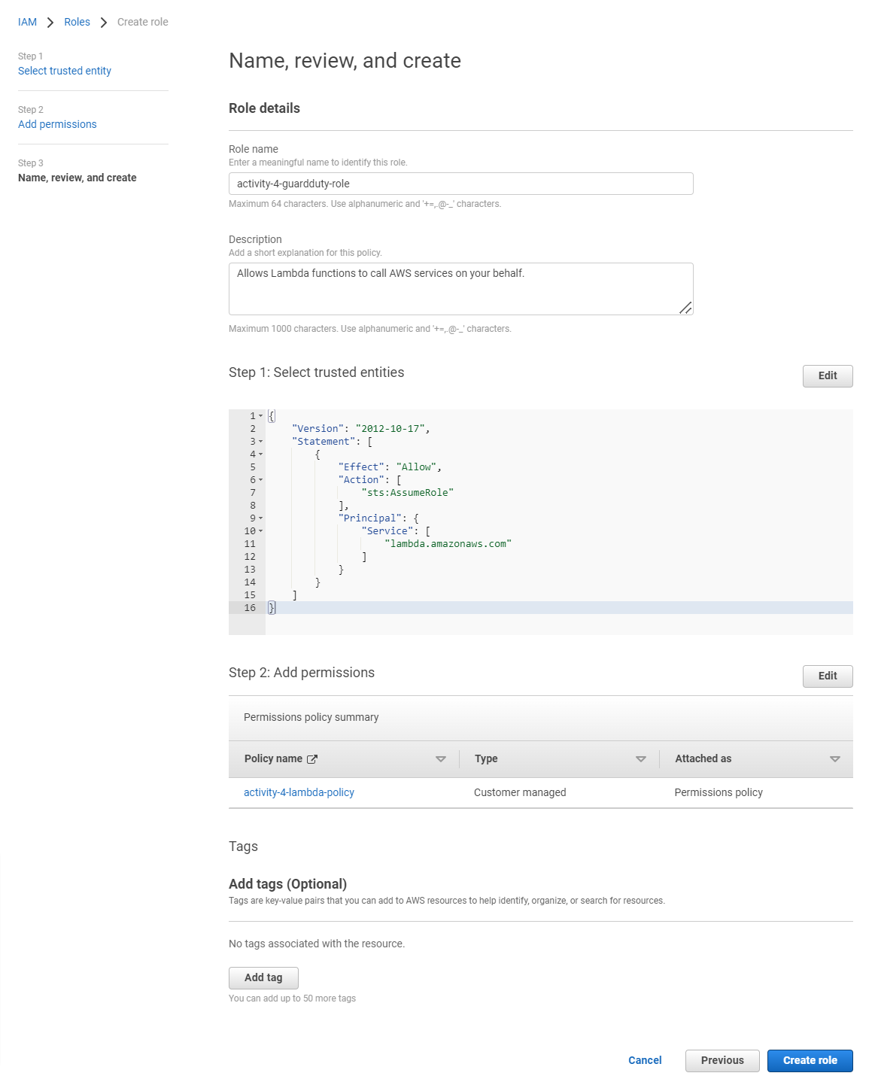

Now, on the left rail nav, choose “Roles”, then press the “Create role” button in the main page body. Leave “AWS service” selected (default), then under “Use case”, select “Lambda” and press the “Next” button. On the “Permissions policies” page, tick the check box next to “activity-4-lambda-policy” to choose it, then scroll to page bottom, and press the “Next” button. On the “Name, review, and create” page, give the Role the name “activity-4-guardduty-role “, scroll to page bottom and press the “Create role” button to finalize the role creation.

**Create Lambda function**

Open another tab in your browser, and in that tab, open a [Lambda console](http://console.aws.amazon.com/lambda/). In the upper right of the main page body, click the “Create function” button. Leave the default “Author from scratch” selected, name the function “guard-duty-check”, select “Python 3.8” as the Runtime, and under “Permissions”, expand “Change default execution role”, and select the radio button next to “Use an existing role”. In the dropdown that gets exposed below, choose the “activity-4-guardduty-role” that you created previously. NOTE: If you don’t see this role, you have to finalize the previous step, and you may have to press the “refresh” button just to the right of this dropdown.

Press the “Create function” button and wait a few seconds until you see the green “Successfully created function **guard-duty-check**” message appear at page top.

Once the message appears, you’ll see the “Code” tab selected in the main page. Browse to the “/activity-4/guard-duty-check.py” code from your github package. Copy that code into your clipboard, and paste it into the code editor in your Lambda console, overwriting the 8 lines of stub code that was pre-populated there for you. Similarly to how you changed YOUR-REGION:YOUR-ACCT-ID in the policy document step earlier, you’ll need to update the “sns_topic_arn” line under “init_global_vars” at the top of the code to put your specific REGION and ACCT_ID in place of the place holders. Press “Deploy” to put your code Live.

NOTE: If you’d like to tinker with the code later on, it’s useful to use “Versions” (far right tab at same level of “Code” to save a version like “Working” once you’ve got a working version of code).

Like all tabs we’ve opened, leave this one open… we’ll come back to it to do some testing later.

**Create EventBridge rule to trigger Lambda function**

Open another tab in your browser, and in that tab, open the [EventBridge console](http://console.aws.amazon.com/events/). From the left rail nav, select “Rules” and in the main page body, click the “Create rule” button. Give your rule the name “process-guardduty-finding”, leave “Rule with an event pattern” (and all other defaults) selected, and press the “Next” button at page bottom.

On the next page, under “Sample event”, in the “Sample events” dropdown, scroll down to “GuardDuty Finding”. The text field will fill with a sample event that would’ve been generated by the GuardDuty service. Click the “Copy” button that appears below that text box to copy this text.

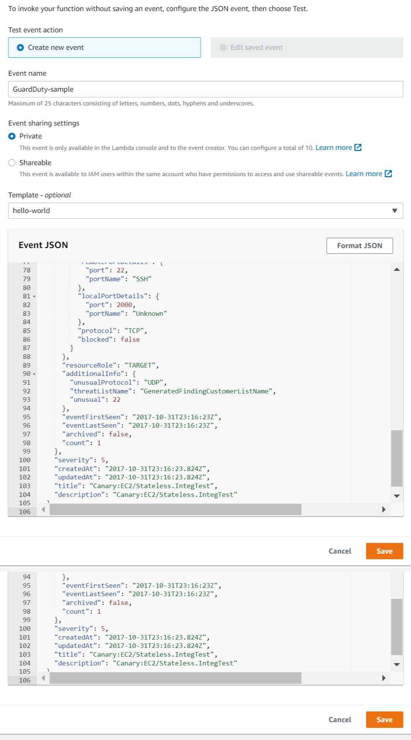Flip back to your Lambda console tab. To the right of the “Test” button on the Code page, click the dropdown button and choose “Configure test event”. Give the event any name (we’ll use “GuardDuty-sample”), and paste in the event code you just copied from EventBridge in the “Event JSON” field (overwriting the text that was pre-populated there for you). Press “Save”. EventBridge gives us a really handy way to capture these events to feed them into our Lambda functions. We’re going to take advantage of **that**!

Leave Lambda console open… we’ll come back and test out a sample event in a bit.

Flib back to your EventBridge tab. At the bottom of the page, under “Event Pattern”, under “AWS service”, scroll down to and select “GuardDuty”. That will expose another drop down below it for “Event type”. In this dropdown, select “GuardDuty Finding” (we’re not interested in CloudTrail events). Press the “Next” button to move the workflow forward.

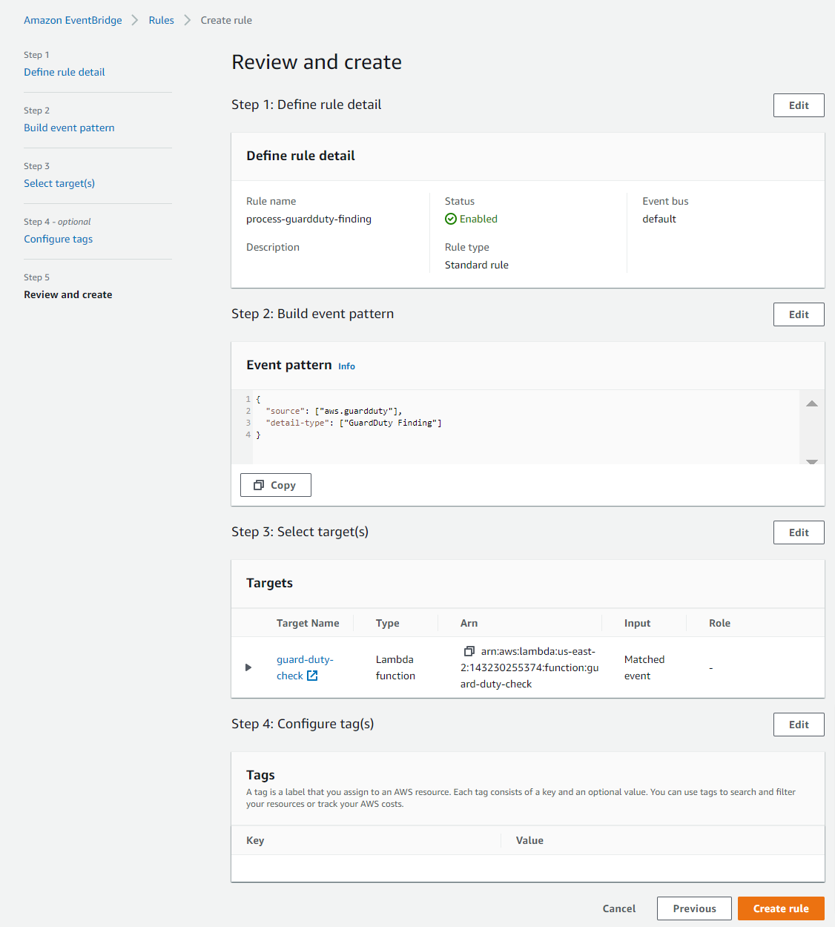On the next page, for “Select target(s)”, leave “AWS service” (the default) selected, and under the dropdown for “Select a target”, choose “Lambda function”, which will expose a “Function” dropdown. From that dropdown, choose your “guard-duty-check” lambda function. Leave all other defaults as-is, and press the “Next” button at page bottom.

On the “Configure tags” page, choose “Next”. And on the “Review and create” page, verify that your settings resemble what is show at the right, and then press “Create rule” to finalize the creation process.

If successful, you’ll see a “Rule process-guardduty-finding’ was created successfully” green message appear at page stop and you’ll have your rule appear in the list below.

**­**

**Test Lambda function with sample event**

Before we let our function finally run wild, we probably want to give it a test, and we just set that up in the last step (thanks to EventBridge being kind enough to supply us with that handy event object!).

Flip back to your Lambda console, and verify that you have successfully set up a Test event (click the dropdown to the right of the “Test” button & verify that you see at least one test – we named ours “GuardDuty-test” in the list that appears. Go ahead & press the “Test” button.

In your email client that you set up to receive your SNS emails, do a search for “to:my@email.com aws notifications”. Verify that you see a single email that looks similar to what we see below:

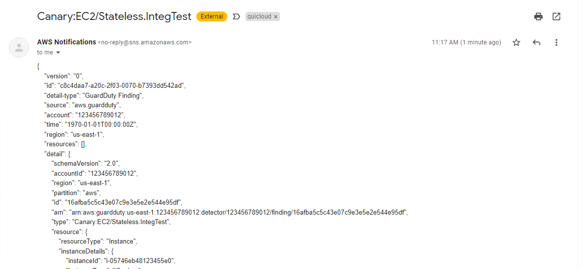

Additionally, if you flip over to the CloudWatch tab in your browser and browse to CloudWatch logs from the left rail nav, and then you choose “Log groups”, you should now see a “guard-duty-check” Log group”, and if you click into it, you should see at least one Log stream. In the most recent entry in the most recent stream, you’ll see a record of this test event. You should see text similar to what is show below (and you can uncomment lines in code to get more detail in the CW logs).

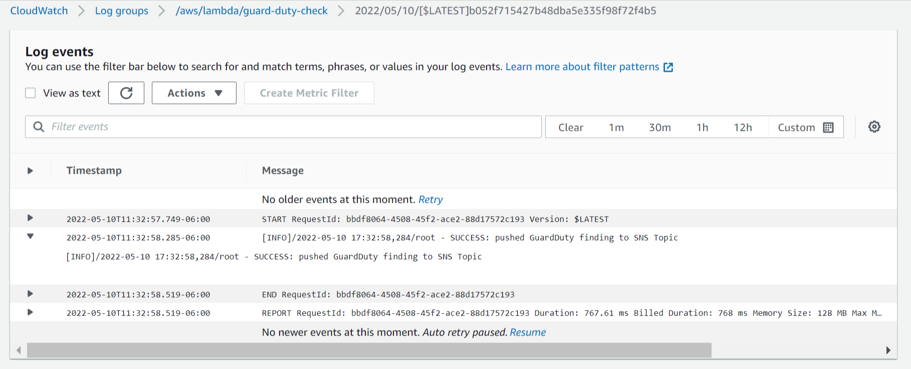As one final check, we can flip over to our Cloudwatch Dashboard that we created previously, “Security”, and we should see that one of the checks (Medium in our case) incremented by 1.

Great! Now it looks like we’re ready to let our horses run free! Let’s throw a deluge of GuardDuty checks at our system and see how it performs!

**Generate sample findings in GuardDuty**

GuardDuty is a **fantastic** service, but it may take a while for it to actually generate findings. What if we don’t want to wait? Well GuardDuty has a fix for that! It has a capability to generate sample findings for us so we can actually see what it would do in the case of finding actual incidences. We’ll use this in our final step to throw an avalanche of findings at our little Lambda function to see how it performs under load.

In our [GuardDuty tab](http://console.aws.amazon.com/guardduty/) (which hopefully we still have open, but if not, take extra care to ensure we’re consistent with the same Region we’ve been using this whole time), select “Settings” from the left rail nav, and in the main page body, scroll down to “Sample findings”.

ONLY PROCEED WITH THIS NEXT STEP ONCE YOU’VE VERIFIED ALL IS WORKING.

1. ARE YOU RECIEVING EMAILS?
2. IS YOUR CLOUDWATCH DASHBOARD UPDATING?
3. ARE YOUR CLOUDWATCH LOGS COMING THROUGH?
4. IS YOUR LAMBDA FUNCTION NOT ERRORING AT ALL?

ONLY IF YOU’RE SURE THE ANSWER TO EACH QUESTION ABOVE IS AN ABSOLUTE ‘**YES**’ DO YOU PROCEED.

Pressing the “Generate sample findings” button on this interface is going to generate dozens of emails in your account. It is going to fill up dozens of entries in your CloudWatch logs. It is going to result in dozens of firings of your Lambda function. *It may result in AWS costs*. Every. Time. You. Press. It. Exercise this button with caution.

Now that you know the danger, let’s go ahead and RELEASE THE KRAKEN!!!

Press the “Generate sample findings” button.

On the left rail nav in GuardDuty, select the “Findings” text to see what you’ve generated. You should see something simliar to what we see in the screenshot below.

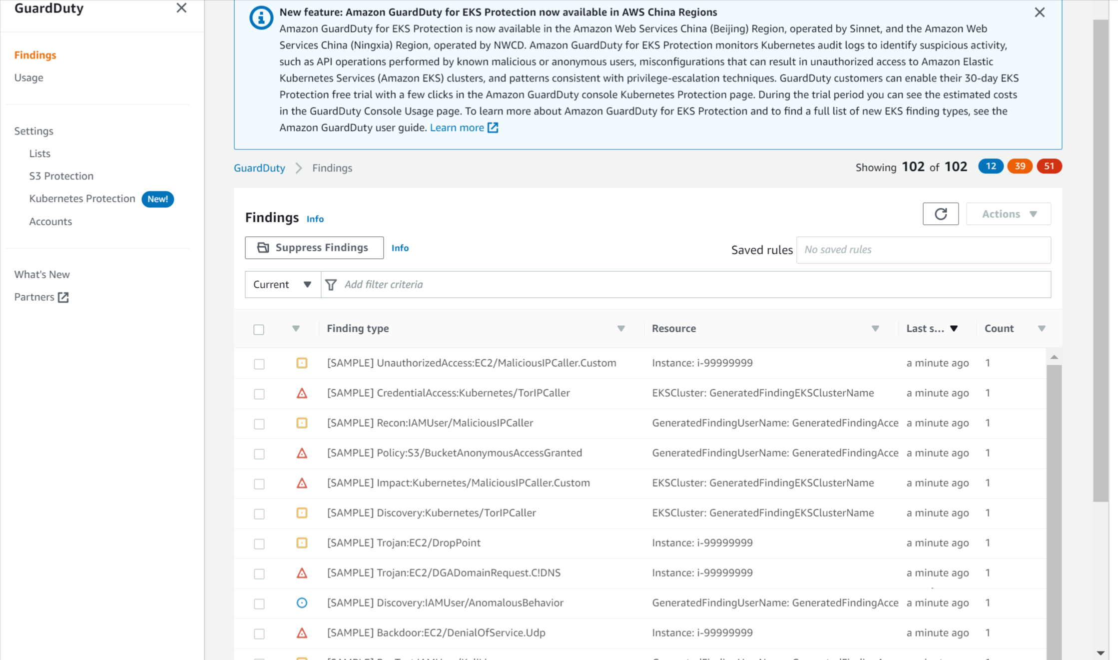

Notice the 12 / 39 / 51 #s for Low, Med, High severity. Correlate this with the 102 emails you just received.

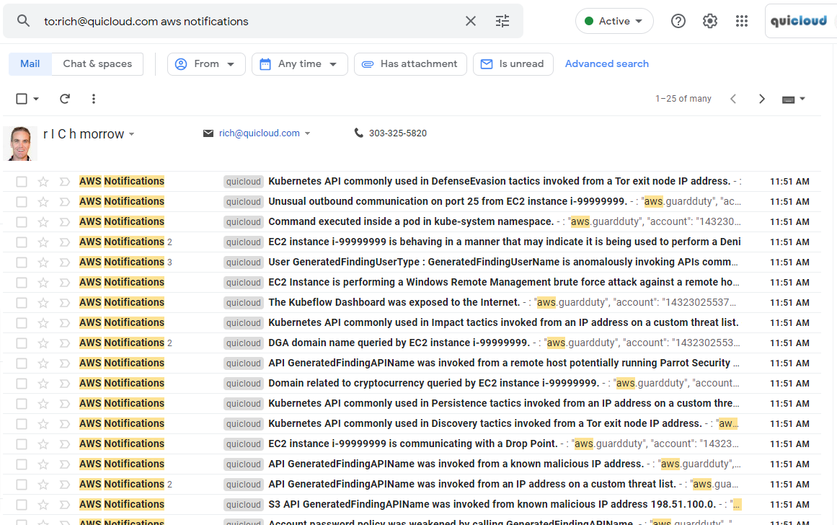

Do the counts match?

Let’s take a look at your CloudWatch Dashboard. Do the counts match there?

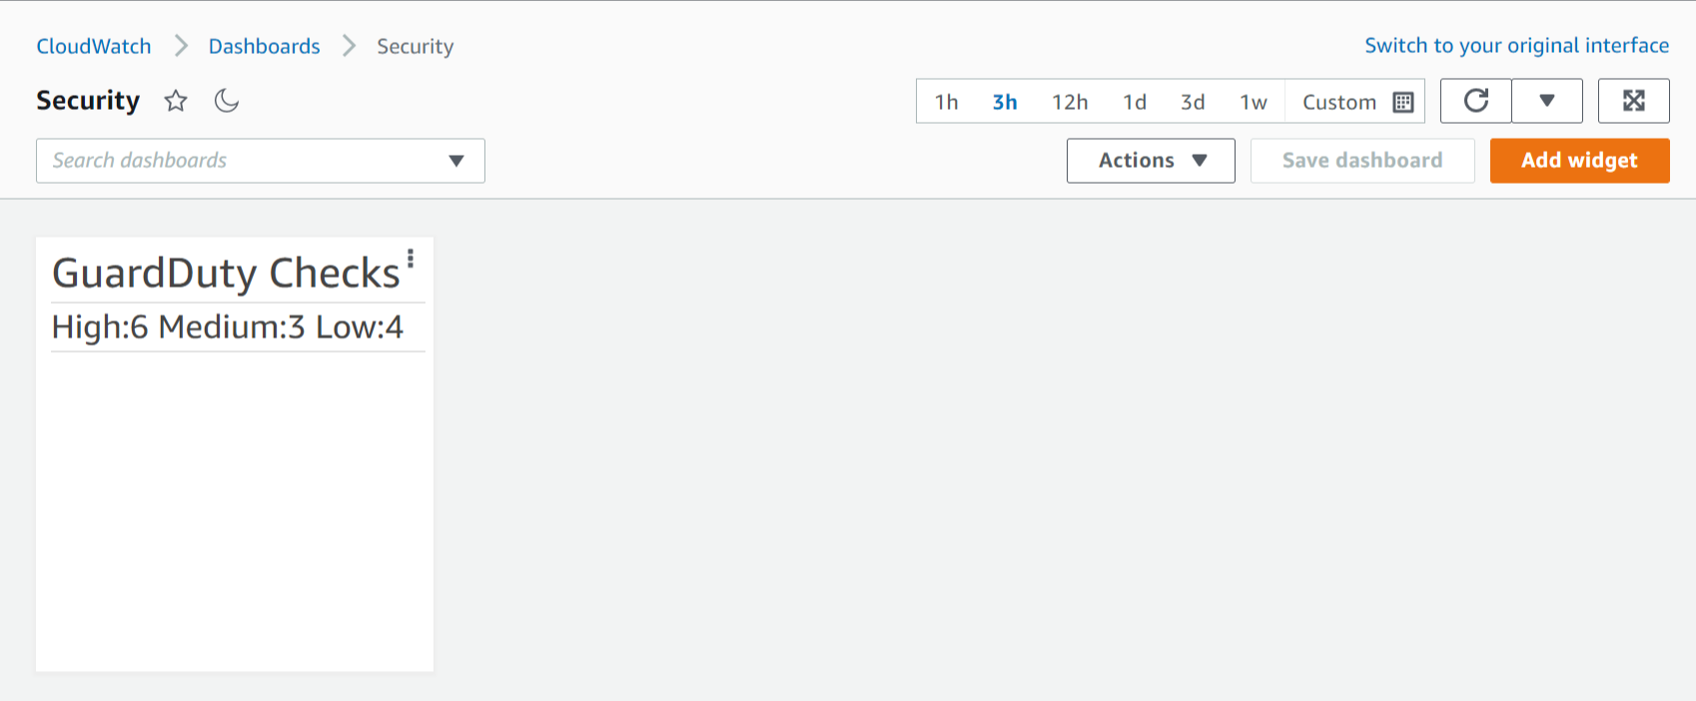

**Questions:**

1. Why do the counts in our CloudWatch Dashboard not match the actual counts we see in GuardDuty?
2. Can we think of a better way to get accurate counts in our Dashboard?
3. How could you rewrite the code (or maybe write other code) to ameliorate the count differences?

********* END OF ACTIVITY #7 STOP HERE!!! *********

You are now able to respond to GuardDuty findings with automated Lambda processors that update dashboards to provide real-time insight into operational issues.